**Inventory Management System**

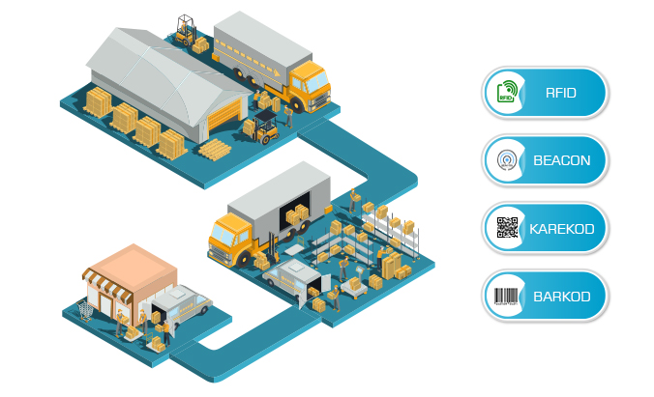

**Mahesh Bist**

00176100

**Computer Project**

**Level 5 Diploma in Computing**

**Email:** bistmahesh333@gmail.com

**Softwarica College of IT & E-Commerce**

**Kathmandu, Nepal**

10/26/2019

**Submitted to: Sudeep lal Bajimaya**

**Abstract**

Inventory Management System (IMS) is Desktop application through C sharp. This system is developed to manage the warehouse product that contain different category. It contain login page to access the system for the authorized user. The home screen of the system contains different buttons like Product, user, stocks, Purchase Invoice, Category, sales and suppliers etc to add, edit, delete and view them.

First of all admin or owner of the system should add the user and then user need to login the system to add, edit, delete and view all Product contained by the warehouse. To add the product in the database first, user need to add the category of the product stocked in the warehouse. The system have other facility to like user of the system also can add, edit, delete and view stocks, sales and suppliers. System also have the facility of barcode which should be unique to identify the every stocks contained by the warehouse.

Every developer has to go through different ways like Analysis, Implementation Deployment, and Testing to develop the system. We can improve the system more effectively with lots of more features if we got long duration.

**Acknowledgement**

The Inventory Management System that I had chosen for the assignment was completed with the guideline of respected teachers those who really helps me. This software development had completed in full guideline of teacher Sudeep lal Bajimaya of Softwarica Collage of IT & E-Commerce. At the beginning I has taken approval about development Inventory Management System for my Computer Project assignment.

In addition, the credit for this development of project goes to all subject relate teacher who have been providing knowledge on software development and teaching me about how to develop system or software from beginning of the Softwarica College.

**Table of Contents**

❖ Introduction 2

❖ Analysis 2

I. Definition 2

II. Methodology 2

III. Feasibility study 5

IV. Software Requirement Specification with MoSCoW prioritization 6

V. Use Case Diagram 10

VI. System Architecture 12

❖ Design 15

i. Sequence Diagram: 15

ii. Activity Diagram: 20

iii. Final Class Diagram: 24

iv. DFD: 25

**Diagram** 27

v. ER Diagram: 28

vi. Data Dictionary: 29

vii. UI modelling (Prototype): 32

viii. Implementation/Coding 36

ix. Testing 36

x. Other Project Issues 36

xi. Conclusion 36

References 37

# Introduction

All this document have full information related to the system about the “Inventory Management System”. The Inventory management system that we have elaborate all over this document is Desktop application that we can access it without any help of internet service.

## Background of Project

Inventory Management system is the popular management system that was throughout certainly in early 1930’s during Industrial Revolution that is used to track and control the inventories of the companies. This management system help to manage stocks, users, sales, Product, Suppliers, and Categories of the small scale as well as the medium scale business.

## Problem Statement

Through this application the authorize users can manage the product, sales, category of the products, stocks available in the company as well keep the data of the supplier companies. The admin or the user can Add, Edit, Delete, and view all the data available in the database. This is desktop application that we create by using C sharp language and will based on object Oriented.

## Aims

## To manage the things or the product of Warehouse which contain different category is the main aims of the Inventory Management system.

## Objectives of the project.

The main objective of the project is to build it and to keep it secure. For the fulfillment of the each and every aim and features we should have to manage data of user, customer, Suppliers, Sales, Sales return, category of the product, Auto transaction option and other. The data that we store through the management system should be able to Update, Delete, View, etc.

Inventory Management system should look so attractive, it should meet all the requirement and should contain full security.

## **Overview of Scope.**

This project include the sales, suppliers, Product. This system helps the owner of the company to save cost and the user of the software to save their time. The development of the application should meet goal with full of security as well as it should be feasible to develop with planned aims & objective.

If the system get crashed the owner may will lost their important data and information which will be the greater disadvantage for them.

## Functionality and Features

* The Users can sign up and login the system.
* User can edit, delete, and view the added products.
* User can add different category of the product.
* Auto calculation can be done in Purchase invoice and sales.
* User can connect the database directly through the application through setting.
* It can add all the detail about supplier as well as can edit, delete and view in the data.

# Analysis

## Definition

* An examination of data and facts to uncover and understand cause-effect relationship, thus providing basis for the problem solving and decision making. It is also known as the systematic way for examination of all the data and information about the project for making its existence in coming future and for getting its essential and important features.
* (karamer, 2014)

## Methodology

* It contain the methodology like Soft approach, hard approach, combine approach, PEST analysis, SWOT analysis, etc.
* The methodology that I am using is **Hard Approach**. It can be used to address both qualitative and quantitative problems. This is step-by-step procedure, which can be iterative, and the process should be revised if new information comes to light ore later stage in the process changes the situational perspective.
* I used this approach because it helps to identify the problem or opportunity. It describe the situation of the system that I am developing. It helps to know that the behaviors of the system in present and future. The main theme of using this approach is it follow and decide the particular route and monitor and evaluate the outcomes.
* (manir, n.d.)

**Figure of hard approach**

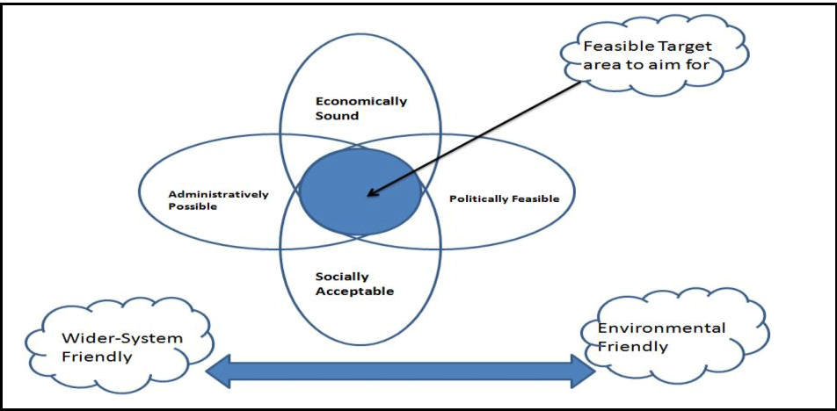

Figure 1: Figure of hard approach.

**Data flow Diagram:**

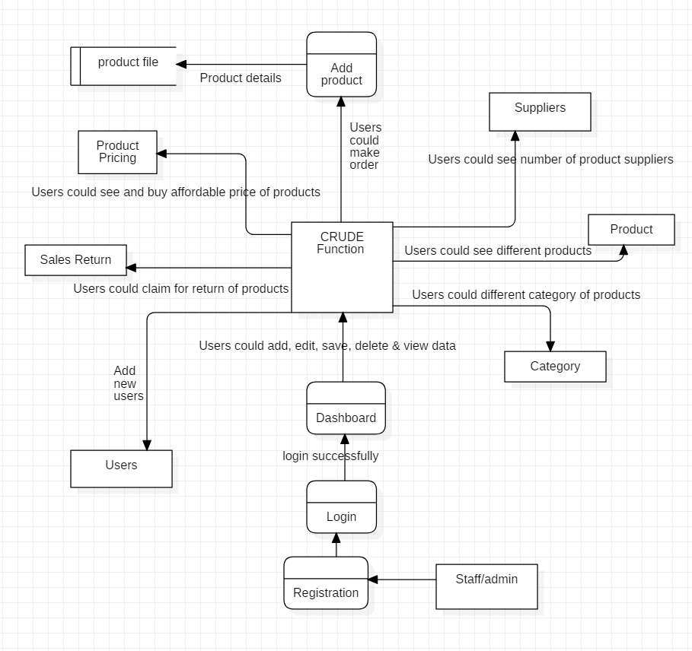

Figure 2: DFD

## Feasibility study

Feasible study is the very first design stage of the certain project, that bring together the elements or the main content of knowledge that indicate if a project is possible or not. It helps to the project whether the project is worthy or not. It is used to determine that if it is technical feasible, is feasible in its estimated cost, will be beneficial or not.

(Farooq, 2016)

**The Inventory Management system should be feasible in the following sectors. So all sector should study.**

* **Social feasibility study:**

The affect which a developing project may have on the social system in the project environment is addressed in the social feasibility. The particular group or the category of the employee may not be available because of ambient social structure. The influence about the social status of the project to the participant should be evaluate for the compatibility.

* **Economic feasibility study:**

This feasibility study tells about feasibility of the developing project to produce economic benefits. The economic feasibility of a project can also be evaluated by a breakeven analysis. It analysis the cost that is needed while developing the project.

* **Legal feasibility study:**

Legal feasibility study about the project means whether the project that we are developing is legally approved by the government or not. If it is not legalize by the government it will not be essential.

* **Political feasibility study:**

Most of the proposed project are dictated by the political consideration. So the terms and condition of the political sector should be agreed while developing the project because further the political factor will not be able to affect the developed project.

* **Scheduling feasibility study:**

It is about the analyzation of the proposed project that is Inventory Management System for management of the time to complete it in given deadline. It the inventory management system is not completed in time it may create so many problems like.

* **Technical feasibility study:**

It tells about the technical resources for the system that you are developing. Inventory Management System is desktop application we need to make sure that what kind of component it needs.

**Information Gathering:**

The information could be gathered for any tasks from different sources like observation, survey, interview, focus group, etc. Similarly, I have gathered information through survey for my task. The questions for my survey goes like:

* What is the value of Inventory Management System in the market?
* How many regular customers are there in the previous project?
* Does the customers are giving the positive feedbacks?
* Is there the possibility of long lasting of the project or not?

## Software Requirement Specification with MoSCoW prioritization

A software requirements specification (SRS) is all about detailed description of Inventory Management system to be developed with its functional and non-functional requirements. System Requirement Specification deals with agreement between Contractors and the Clients. (Krüger, 2018)

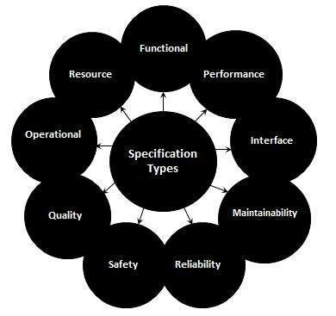

Figure 3: SRS.

**Mainly it contain Functional and Non-functional requirement which are illustrate below**

**Functional Requirement:**

The identification and declaration of the intended function of inventory management system and its component is called functional requirements. It define what a system is supposed to do. The early form of the functional requirement is system design. It can be related to both hardware, software or the both in term of calculation, technical detail, data manipulation and other specific functionality.

**Non-functional Requirement:**

Non-functional requirement (NFR) is a requirement that intend to judge the operation of a system, rather than its particular or the specific behaviors and functions. It basically define how a system is supposed to be. It have executive quality such as safety, security, as well as usability which are observed at run time and Evolutionary quality such as testability, maintainability, extensibility, scalability involved in the internal structure of the system.

**The identification of functional and non-functional requirement with MoSCoW prioritization is tabulate in the table below.**

In the table the indexes used for functional, non-function and MoSCoW are:

**M**: Most Have

**S**: Should Have

**C**: Could Have

**F**: Functional Requirement

**NF**: Non-functional Requirement

**Functional Requirements with MoSCoW prioritization:**

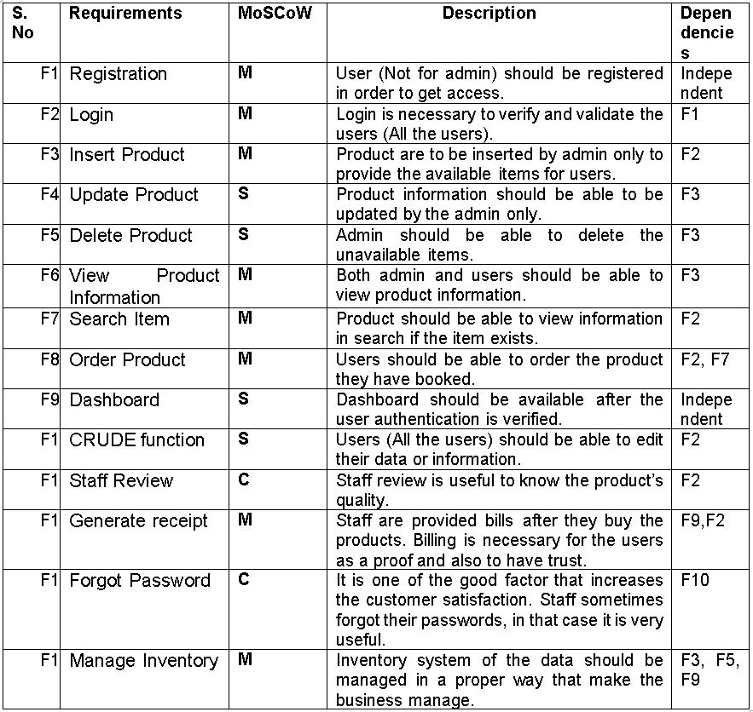

**Non-Functional Requirements with MoSCoW prioritization:**

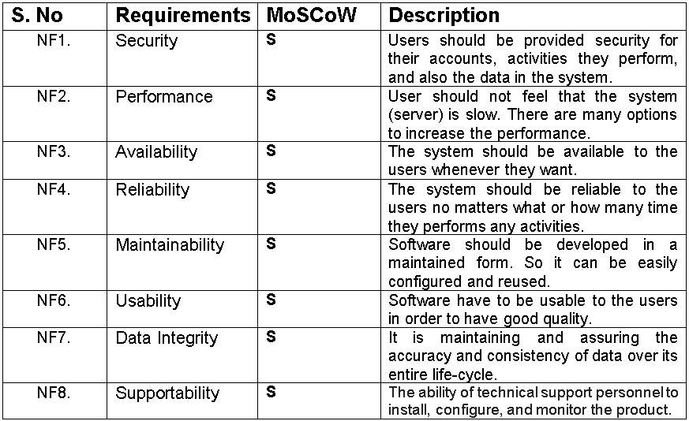

## Use Case Diagram

It is the dynamic diagram work to show the behavior systems behavior which you have developed is called use case diagram. It is used to show then relationship and behavior between, system and use case and actors. The main work of this diagram is to show about the system users and the users who are interacting with the developed system. It helps to show the main aim they have to achieve from system. It helps to find the system functionality at analysis phase. This system separate the system into use case and the actors where actor represent as the user of system. (apploy, 2016)

The Use Case Diagram contain the following components:

* **Actors**

Actor is denoted by the stick figure. Which denote the users of the system.



* **Use cases**

It provide the description of the process. And contain oval shave structure.

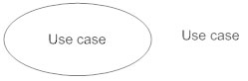

* **Relationship**

It show the relationship between the use case of the system and the actors.

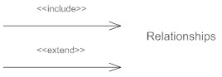

**Use case diagram**

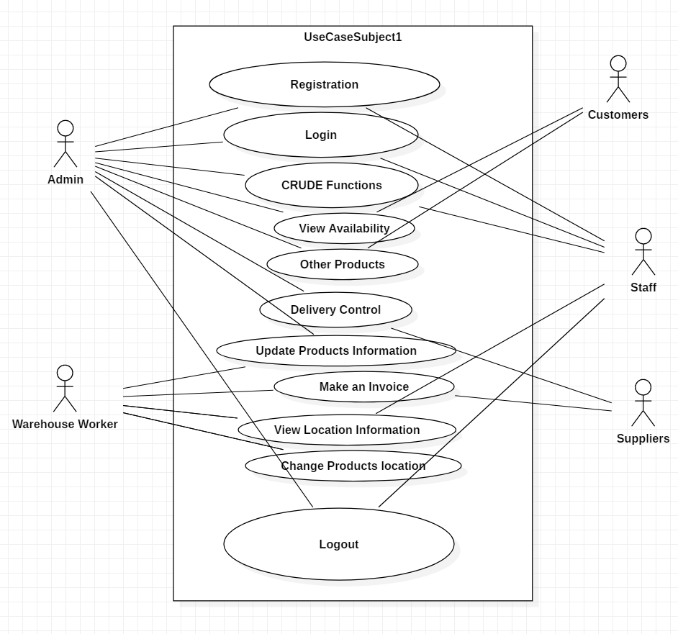

Figure 4: Use case diagram

## System Architecture

**Background of the project:**

For the management of medium and small scale business you have to develop secure Inventory Management System. In this system of management the staff or admin should be able to add or Update, Edit, Delete the data for the management of business. To access the system the user need to register for accessing the inventory management system then only you can be able to login the system. The dashboard of the management system require the options User, Products, Stocks, Suppliers, Categories, Purchase invoice, Sales, Product Pricing, Sales return, etc. On accessing or clicking these option every particular option must contain CRUDE function.

The user of the system can deal with other companies for the good supply. After the supply of the goods the owner company should be able to store the Product data, sales data, supply data and other through this system as well as able to print out the invoice of Product purchase through this Inventory Management system.

**Natural Language Analysis:**

The separation of noun and verb for the candidate class are tabulate in the table below:

|  |  |
| --- | --- |
| **Nouns** | **Verbs** |
| Business, Scale, Inventory, system, Login, dashboard, staffs, admin, Product pricing, sales, Stocks, Suppliers, Purchase invoice, option, companies, good supply, Product data, sales data, etc. | Develop, manage, register, category, sales return, function, store, purchase, print, supply, Add, Update, Delete, edit, create, etc. |

From above table of noun and verb we select the appropriate noun and verb for the construction of the Initial class diagram.

**Initial Class Diagram:**

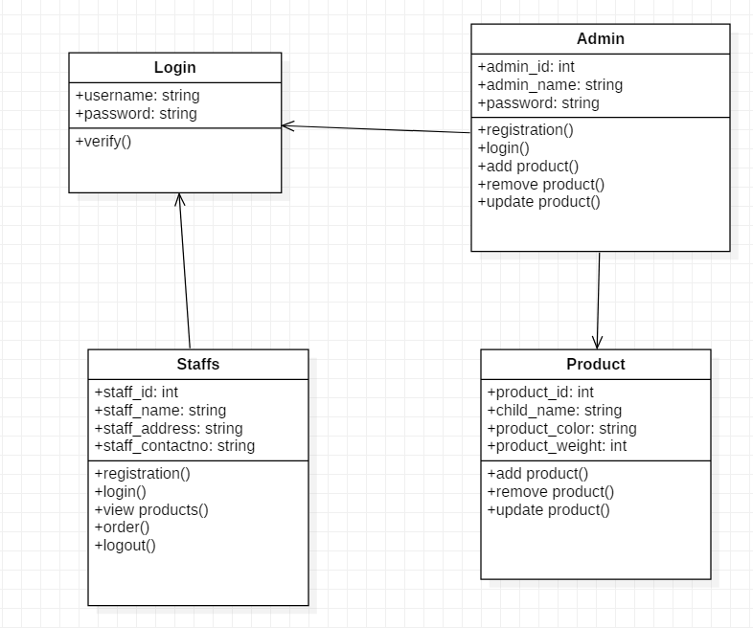

Figure 5: Initial class diagram

**System architecture definition:**

Inventory Management system use 3-tier architecture that have three layer which are Presentation layer, Application layer and database server. Presentation layer contain the PC, Tablet, Mobile, etc. and Application Layer that deals with the server. (Dale, 2017)

**The three-tier architecture have following goals:**

* The user application and the physical database are separated by the three-tier architecture.
* It helps to support DBMS characteristics.
* Program-data independence.
* It helps to support the multiple data of the system.

**System architecture diagram:**

[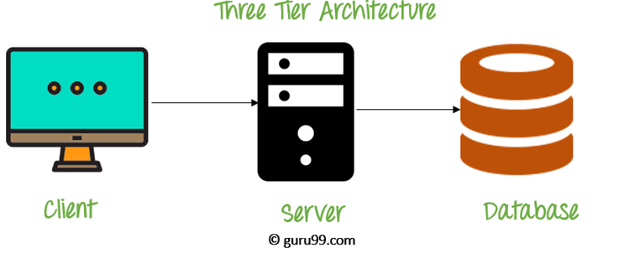](https://www.guru99.com/images/1/091318_0745_DBMSArchite3.png)

Figure 6: three-tier architecture

# Design

**Dynamic Modelling**

## Sequence Diagram:

A kind of diagram that arrange the interaction of the object in the time sequence. It is also called the event diagram. It describe how the classes are interacting with each other while exchanging message over time. It helps to validate and visualize different runtime scenarios. It contain parallel vertical line that we called the lifeline also contain object or the process simultaneously. (Gary Afable, 2010)

**Justifications:**

We used to draw this diagram at the requirement period of certain period. It is important to create this diagram because it helps to show the behavior of different object which we are going to develop in our certain projects. Through this the collaboration of the object can be shown.

**Advantages:**

* It is quite helpful for the developer and analyst of the business to get common or the basic understanding.
* It is used to validate class diagrams against use case in object orientated analysis as well as it helps to show the timing interacting of objects or the entities.

**Disadvantages:**

* It must be elaborate and define for every possible scenario and need fully defined class module.

**Notation used:**

It also contain different following notations while creating the basic sequence diagram.

* + **Class Roles or Participants**

The main role of participant is to show how an object is going to behave in context.

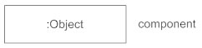

* + **Activation or Execution occurrence**

It is the vertical boxes that used to place on the lifeline and helps to show how much time an object needed for the completion of task.

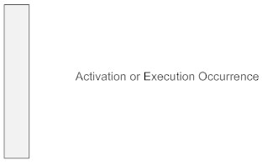

* + **Messages**

It represent the arrows that can be dotted or non-dotted and helps to shows the communication between various objects.

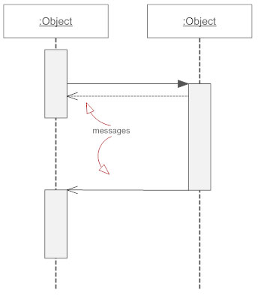

**There are different kinds of messages which are listed below:**









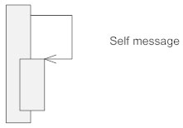

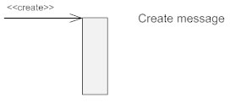

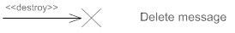

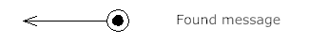

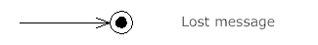

* + **Lifelines**

The vertical dotted line that we connect through the object represent the lifeline.

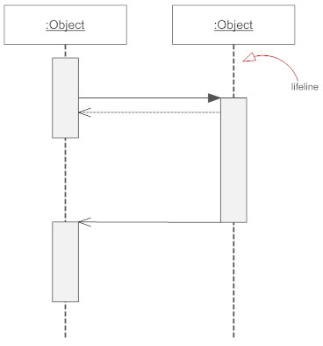

**Sequence Diagram**

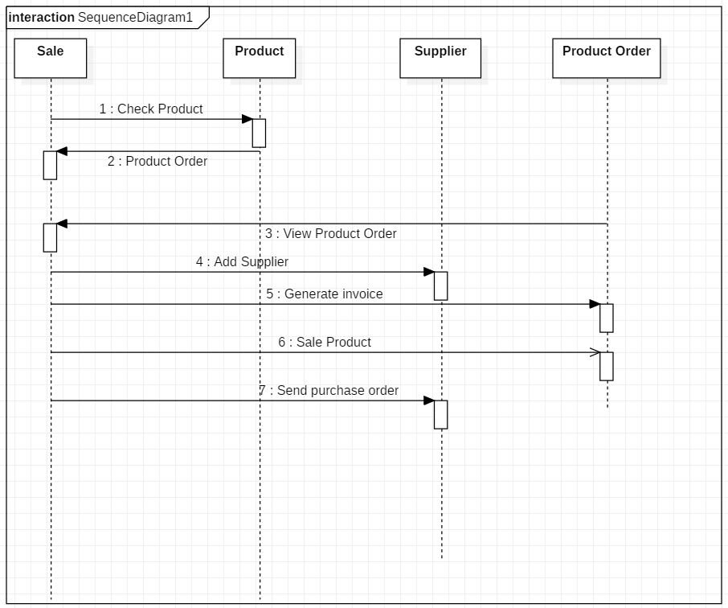

Figure 7: Item Sequence Diagram

**Description**

It interact among classes or entities above the diagram that are Sale, Product, Supplier, and Product Order in terms of exchanging the message or showing the activity done to manage the business through the inventory management system. It tell about each and every action that user have to do after accessing the Inventory Management system.

## Activity Diagram:

Activity diagram is also known as the behavioral diagram that describes all the dynamic aspect that contained by the system. It is more advanced then the flow chat diagram. It describe the flow of the system or the flow of activity. (Ivory-Ndiaye, 2013)

**Justifications:**

They are used for all the stages of system or the software development. Activity diagram helps to describe how the system will show the flow of one activity to another activity. It make the developer as well as the user to understand the system easily. It is quite similar to a flowchart or data flow diagram.

**Advantages:**

* It deals with the control flow, it means how the system flow logically.
* It will show how the system will behave when it is interacted.
* It helps the user or the developer to know how the operations are getting performed.

**Disadvantages:**

* Activity diagram does not describe in detail, that how the system behave and because of this problem they may not be used in lieu sequence diagram.

**Notation used:**

While creating the activity diagram different notation are used which are listed below:

* + **Activity**

It helps to show the set of actions

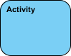

* + **Action**

Used to perform the task.



* + **Control flow**

It represent the sequence of flow or execution.



* + **Object flow**

Show the flow of object from one action to another.



* + **Initial Node**

Used for beginning the diagram.



* + **Activity final node**

Used to end or stop the diagram.



* + **Object node**

It helps to represent the objects.



* + **Decision node**

It decide where action have to flow in activity.

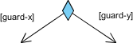

* + **Merge node**

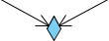

* + **Fork node**

Behavior split into parallel flow of actions.

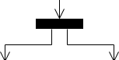

* + **Joint node**

Unite together the set of concurrent actions.



* + **Swim lane or partition**

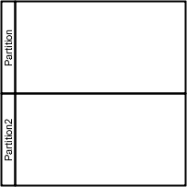

**Activity Diagram**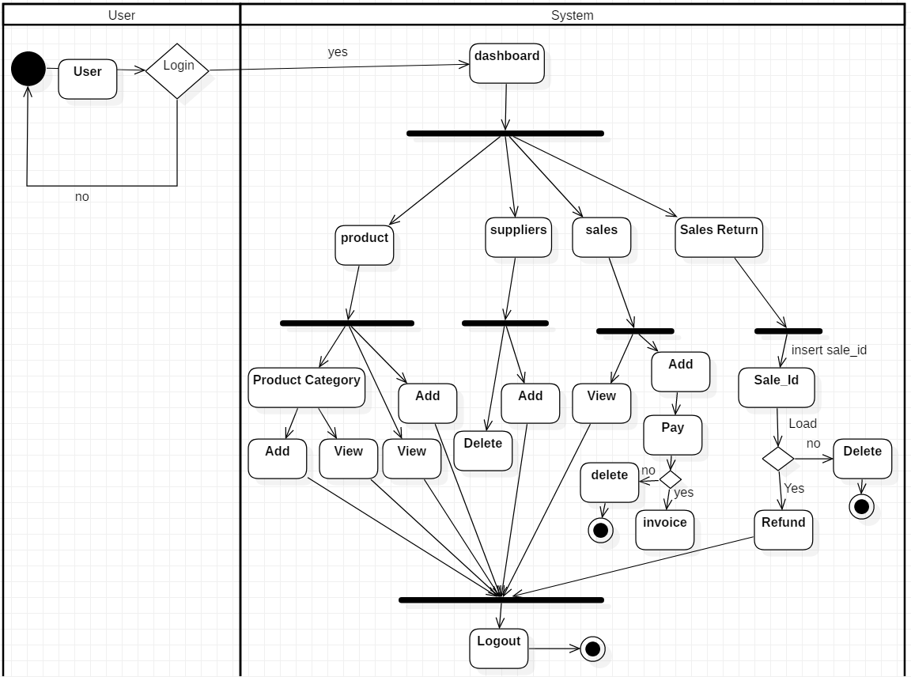

Figure 8: Activity Diagram

**Description of the system**

According to the system first of all the user need to ‘login’ the system, then only the user will able to open the ‘dashboard’. In dashboard you will have different option to manage the system. The option like Stock Supplier, Product, sales return etc. Also, in all particular option it contain Add, View, Edit, Delete the particulars data like, ‘Supplier’ option contain Add Supplier, Delete supplier, Edit supplier etc. Product also contain Add Product, View Product, Delete Product, after clicking the option product. Beside these it have some other options which do their particular work and finally the user can ‘logout’ after the completion of management.

**Structural Modelling**

## Final Class Diagram:

It the kinds of diagram that made to provide some overview as well as its logical structure of the software in terms of attributes, in terms of classes, methods, as well as relationship between the various classes. It helps to show the structure of the system that we are developing.

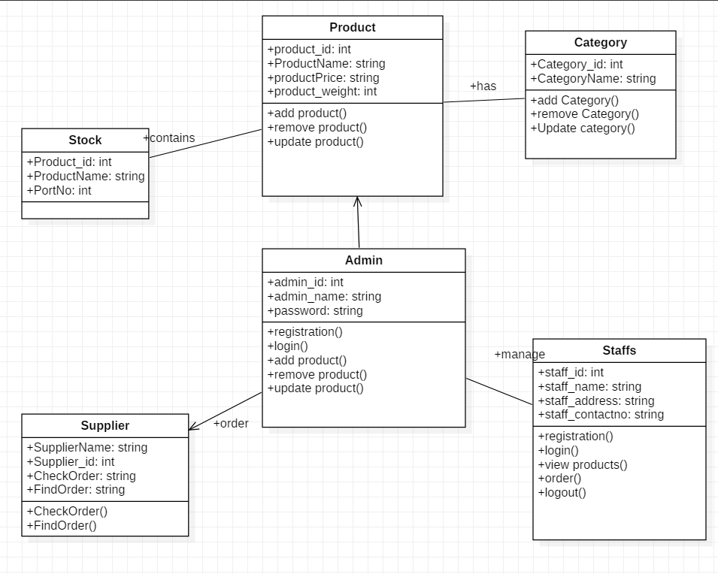

Figure 9: Final Class Diagram

**Description of Diagram**

The stock contains product. One stock contains more than one product. The product has category. In stock there is staff and admin which manage the product. All the product is manage by admin. The product is supplied by supplier.

## DFD:

DFD means the data flow diagram that show the follow of data and information in a certain system and how the system process it in terms of input and output. It really focus on data and information of the certain system where it come and where it go. It became so modified and popular in 1970s for the development of the system and software. (jira, 2010)

**Why DFD:**

Through data flow Diagram, we can give the overview of the software or the system without going the deep detail of the system.

**Some important point:**

* Name should be unique.
* Decision paths (diamond node) represent logical expression.
* DFDs depict flow of data and not order of events like a flowchart.

**Notations used:**

1. **External entity:**

These are the object that are used in communication and found outside of the system. They are so much helpful in sending and receiving the data and information as input and output.

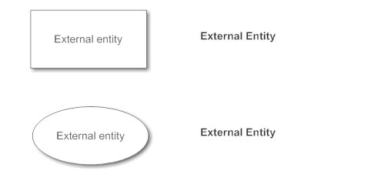

1. **Process Notation:**

It is used to change the data. Here incoming data flow got changed into outgoing data flow.

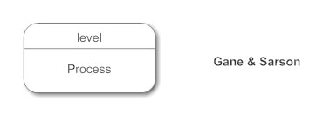

1. **Data Store Notation:**

Data store is like a place where data and information of the system store. It is like a repository for the data.

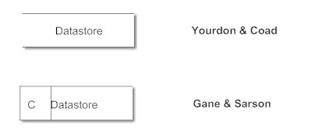

1. **Data Flow:**

It is the way where the data and information used to flow. They are like Pipeline which are denoted by the arrows.

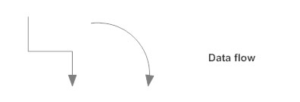

## **Diagram**

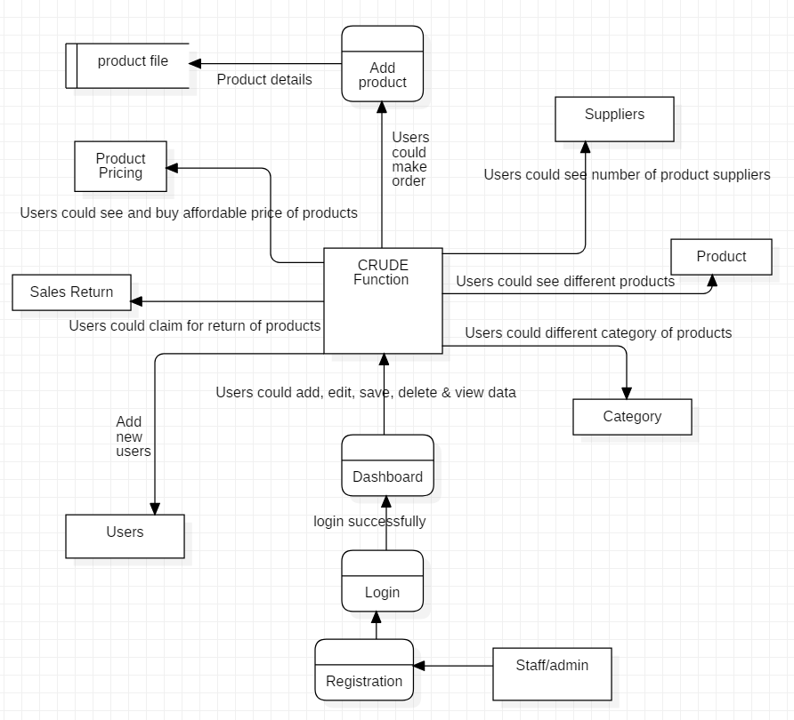

Figure 10: DFD for inventory management system

**Database Modelling**

## ER Diagram:

ER diagram is conceptual module and representational module which is used to show the relationship between different classes which are stored in the database. It is more helpful to design the database. It contain so many symbols and connector and illustrate the logical structure of database. (toyee, 2010)

**Why ER diagram:**

Through ER diagram it make the developer easy to understand the Database. It is high level conceptual module which is easy if we have the idea about entity relationship. It is also the good communication tool to design the Database.

**ER Diagram:**

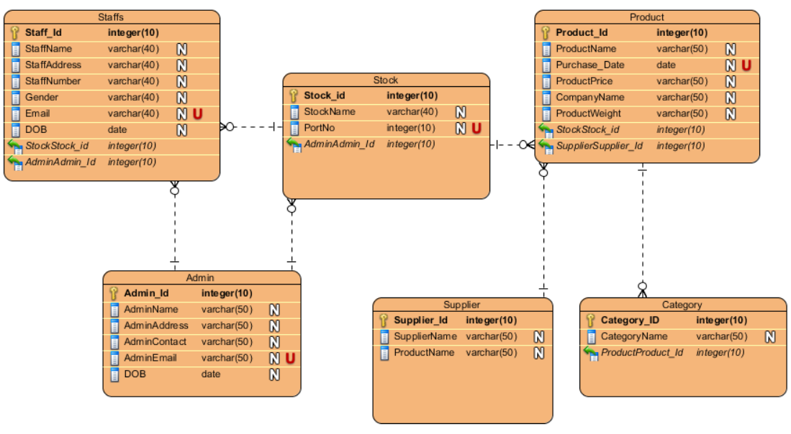

Figure 11: ER Diagram

**Description of the diagram**

Above Entity Relationship diagram contain six class or the Entity named Staff, Suppliers, Products, Admin, Stocks, and the category which illustrate the category of the products. Each and Every particular entity contain one unique primary key, and one unique key. They are connected with each other by one to many and many to one function. Suppose, Product have many category which contain one to many relation respectively.

## Data Dictionary:

Data dictionary is the Place where we used to keep the details of the content of data flow process and data store. It is data about data which define different element like data element. Data element is the smallest unit. It also contain Data structure which handle as a unit.

**Staff Table**

|  |  |  |  |  |
| --- | --- | --- | --- | --- |
| **S.No.** | **Field Name** | **Data type** | **Length** | **Constraints** |
| 1 | Staff_id | integer | 10 | primary |
| 2 | Staff Name | varchar | 40 | - |
| 3 | Staff Address | varchar | 40 | - |
| 4 | Staff Number | integer | 10 | - |
| 5 | Gender | varchar | 50 | - |
| 6 | Email | varchar | 50 | Unique |
| 7 | DOB | date | 0 | - |
| 8 | Stock_id | integer | 10 | - |
| 9 | Admin_id | integer | 10 | - |

Figure 12: Staff Data Dictionary

**Stock table**

|  |  |  |  |  |
| --- | --- | --- | --- | --- |
| **S.No.** | **Field Name** | **Data type** | **Length** | **Constraints** |
| 1 | Staff_id | integer | 10 | primary |
| 2 | Stoke Name | varchar | 40 | - |
| 3 | PortNo | varchar | 40 | - |
| 4 | Admin_id | integer | 10 | - |

Figure 13: Stock Data Dictionary

**Product Table**

|  |  |  |  |  |
| --- | --- | --- | --- | --- |
| **S.No.** | **Field Name** | **Data type** | **Length** | **Constraints** |
| 1 | Product_id | integer | 10 | primary |
| 2 | Product Name | varchar | 50 | - |
| 3 | Purchase Date | varchar | 50 | Unique |
| 4 | Product Price | integer | 10 | - |
| 5 | Product Weight | varchar | 50 | - |
| 8 | Stock_id | integer | 10 | foreign |
| 9 | Supplier_id | integer | 10 | foreign |

Figure 14: Item Type Data Dictionary

**Supplier table**

|  |  |  |  |  |
| --- | --- | --- | --- | --- |
| **S.No.** | **Field Name** | **Data type** | **Length** | **Constraints** |
| 1 | Supplier_id | integer | 10 | primary |
| 2 | Supplier Name | varchar | 50 | - |
| 3 | Product Name | varchar | 50 | - |

Figure 15: Supplier Data Dictionary

**Supplier table**

|  |  |  |  |  |
| --- | --- | --- | --- | --- |
| **S.No.** | **Field Name** | **Data type** | **Length** | **Constraints** |
| 1 | Category_id | integer | 10 | primary |
| 2 | Category Name | varchar | 50 | - |
| 3 | Product_id | integer | 10 | foreign |

Figure 16: Category Data Dictionary

**Supplier table**

|  |  |  |  |  |
| --- | --- | --- | --- | --- |
| **S.No.** | **Field Name** | **Data type** | **Length** | **Constraints** |
| 1 | Admin_id | integer | 10 | primary |
| 2 | Admin Name | varchar | 50 | - |
| 3 | Admin Address | integer | 10 | - |
| 4 | Admin Contact | varchar | 50 | - |
| 5 | Admin Email | varchar | 50 | - |
| 6 | DOB | date | 0 | - |

Figure 17: Admin Data Dictionary

## UI modelling (Prototype):

Prototype is used to describe the system logically before the development of the system. It helps to make the client easy to understand the system. It also helps to make the developer easy to develop the system. Prototype is known as the roughly drawn diagram to know the different interface of the system.

1. **Login Page:**

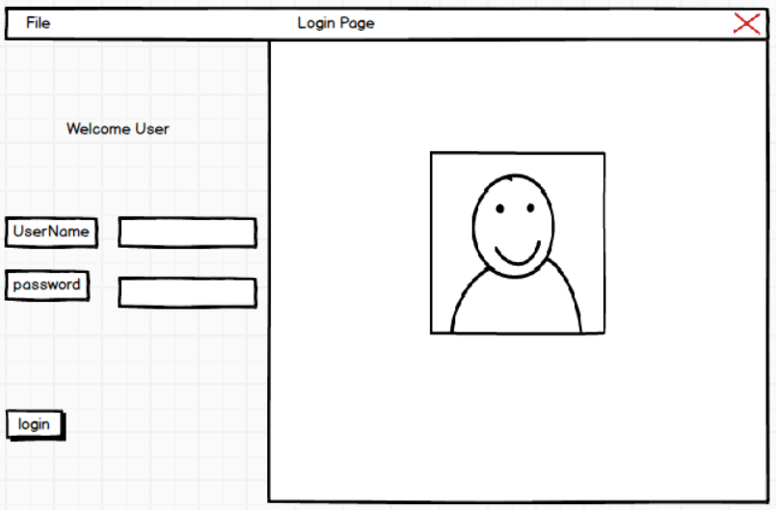

Figure 18: Login Page Prototype

1. **User Page:**

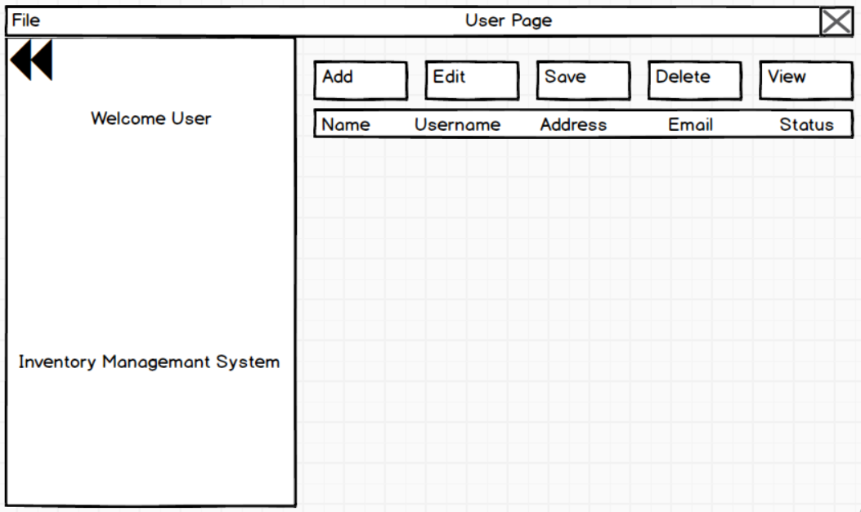

Figure 19: User Page Prototype

1. **Home Page:**

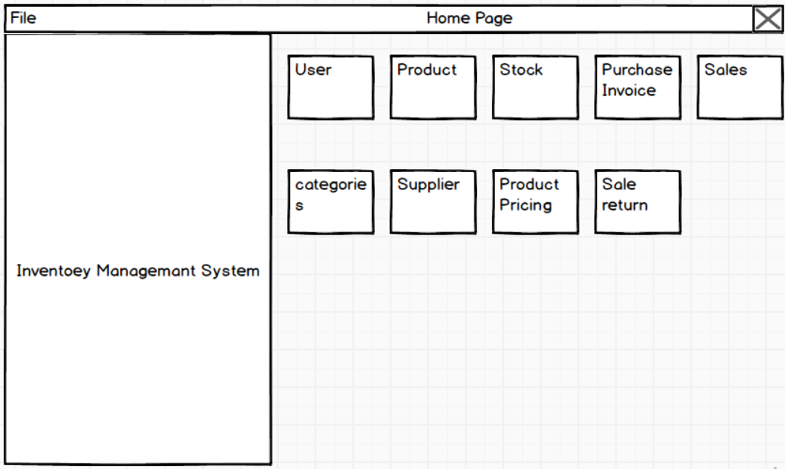

Figure 20: Home Page Prototype

1. **Sales Page:**

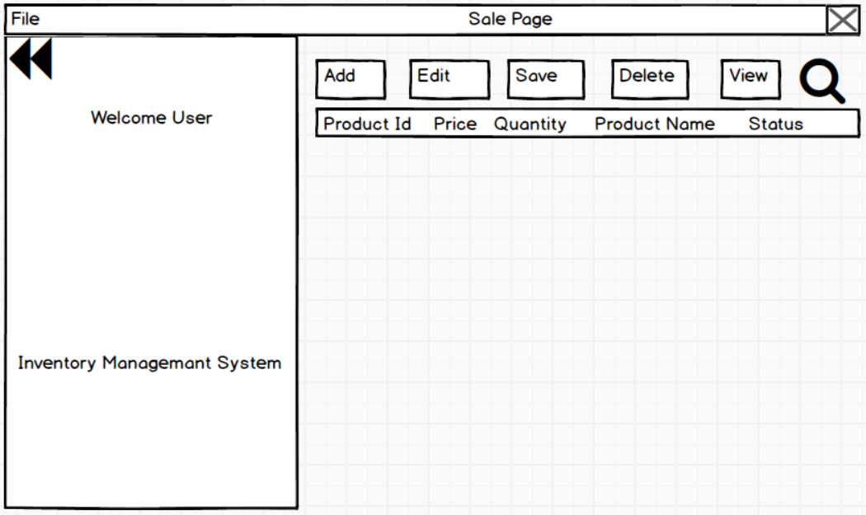

Figure 21: Sales Page Prototype

1. **Supplier Page;**

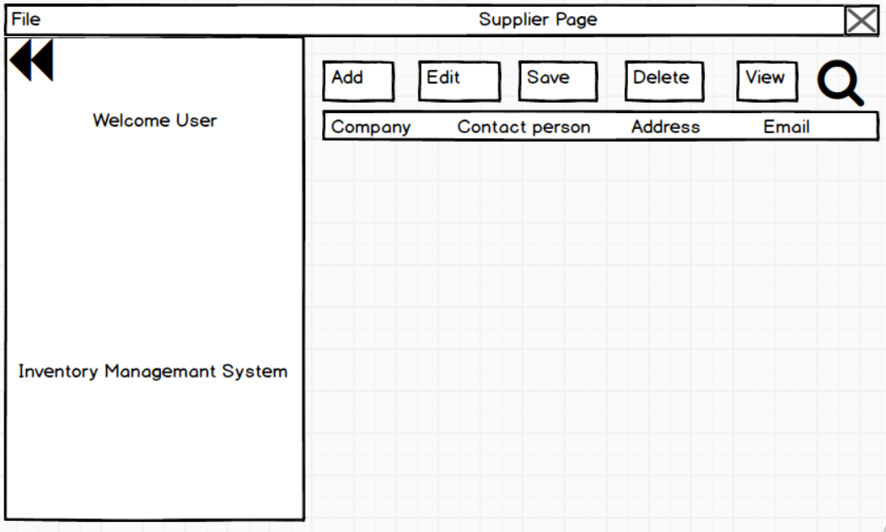

Figure 22: Supplier Page Prototype

# Implementation/Coding

This is the phase where we used to start Our Coding to develop the system according to our analysis by using the best design approach.

**Language Chosen/Framework**

This is the desktop application to manage the stock, product, user and other used to manage in the inventory management system. The language that I have choose to develop this application is C sharp. Through visual studio the system get to develop by using the C sharp language.

**Database Management System**

SQL server is used in this development of Application as a database to store the added the data through the application. I have used so many quarries to create different tables and to create different procedure to connect the application to the database.

**All the Code of the Implementation are included in Appendix.**

# Testing

## Introduction

Testing deals the process where it investigate, evaluate, and ascertain the completion of the software with its complete quality. It helps to identify different errors, gaps as well as missing requirements. Through this process we can make our software durable.

## Testing type

There are two types that I have done in this project. It contain Unit Testing and Black Box testing.

## Unit Testing

In this testing individual units or component of the developed software are tested. It helps to know the developer about the unfixed issued and helps to notice and fix them. This testing include the validation testing. It has few input and usually have single output. The smallest unit called method which are the most usable things to test the software.

**Screenshot of Unit testing**

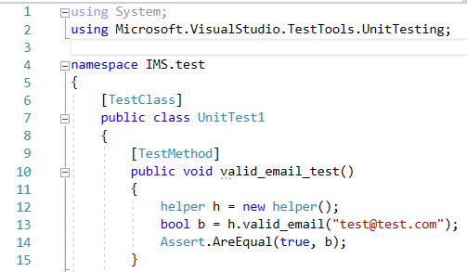

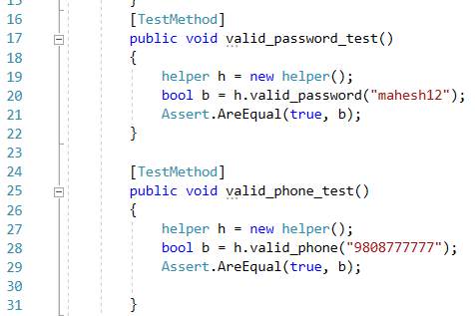

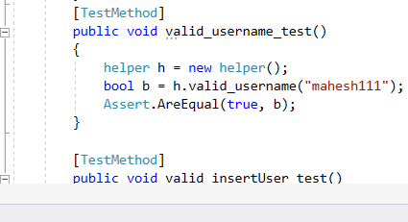

**Screenshot of Successful Unit Testing:**

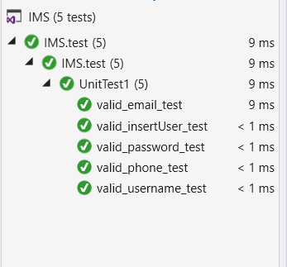

## Black Box Testing

This is the kinds of testing that simply show input and output to show the data are valid and invalid. If result output got pass then it show the Expected result successful otherwise it show fail.

The unsuccessful data that is teste is noticed with red highlight and successful data with normal white highlight.

|  |  |  |  |  |  |  |
| --- | --- | --- | --- | --- | --- | --- |
| **ID** | **Test Case & Description** | **Test Data** | **Expected Results** | **Actual Results** | **Status** | **Remark** |
| **Login** | | | | | | |
| 1 | Verification of user name and Password | mahesh, mahesh | Success | Unsuccessful with incorrect username or password. | Failed | Incorrect username or password |
| 2 | Verify user name and Password | mahesh, mahesh | successful | login successful | passed |  |
| User | | | | | | |
| 3 | Add new user | Fill up all field required data | User added successfully | Please fill up all fields | Failed | Null values not accepted |
| 4 | Add new user | Add all required data | User added successfully | Successfully  Added | passed |  |
| Search User | | | | | | |
| 5 | Data search | mahesh | Successful | data not shown | Failed | Enter existing data |
| 6 | Data search | mahesh | Successfully searched | Successful found | passed |  |
| Search Supplier | | | | | | |
| 7 | Search Supplier | Tech company | Supplier found | Data not shown | Failed | Add exising data |
| 8 | Search Supplier | Tech Company | Supplier found | supplier found | passed |  |
| Product | | | | | | |
| 9 | Add New Product | Fill all mandatory fields | Product added | Every field is mandatory | Failed | All field are necessary |
| 10 | Add New Product | Fill all mandatory fields | Product added | Product added successfully | Passed |  |
| Delete Product | | | | | | |
| 11 | Delete Product | Select row to delete | Product deleted | Product not selected | Failed | Product need to select |
| 12 | Delete Product | Select row to delete | Product deleted | Product Deleted successfully | Passed |  |
| Setting | | | | | | |
| 13 | Connect database SQL server | Fill all mandatory fields | Database Connected | All field are mandatory | Failed | Enter all the Data |
| 14 | Connect database SQL server | Fill all mandatory fields | Database Connected | Connected Successfully | Passed |  |
| View Category | | | | | | |
| 15 | View Category | Select view button | It should view data | No data | Failed | Category should be added |
| 16 | View Category | Select view button | It should view data | Data shown | Passed |  |
| Delete Category | | | | | | |
| 17 | Delete Category | Click Delete button | Data Deleted Successfully | Not deleted | Failed | Data not selected |
| 18 | Delete Category | Click Delete button | Data Deleted Successfully | Deleted successfully | Passed |  |
| View Stock | | | | | | |
| 19 | View Stock | Click View button | All added stock should view in row | No data | Failed | User need to add stock to view it |
| 20 | View Stock | Click View button | All added stock should view in row | Data Shown | Passed |  |

# Other Project Issues

## Risk Management

Risk Management is one of the very important management for the project because in future the project may have to face different kinds of risky events like time shortage, budget shortage, hardware failure, or system may can contain threats, Requirement may will not meet, natural disaster etc. The likelihood of occurring these risk can be high, medium and low as well as consequences depend on the likelihood of risks.

**Note: Impact = Likelihood *Consequence**

* Risk likelihood values are:

|  |  |
| --- | --- |
| **Likelihood** | **Value** |
| Low | 1 |
| Medium | 2 |
| High | 3 |

Table: Likelihood

* Risk consequence values are:

|  |  |
| --- | --- |
| **Consequence** | **Value** |
| Very low | 1 |
| Low | 2 |
| Medium | 3 |
| High | 4 |
| Very high | 5 |

Different kinds of Risks with variable Likelihood and consequences

|  |  |  |  |  |  |
| --- | --- | --- | --- | --- | --- |
| **R.N** | **Risk** | **Likeli-**  **hood** | **Cons**  **equence** | **Impact** | **Action** |
| 1 | Hardware Failure | 2 | 5 | 10 | Data backup should be done after the completion of certain work or the piece of work. Qualitative hardware should be use. |
| 2 | Time Limitation | 2 | 4 | 8 | Time allocation and  100% should be given. |
| 3 | Budget shortage |  |  |  | Estimation should be done in time. |
| 4 | Misdirection of project and  Project resource not met | 1 | 4 | 4 | Requirement gathering as well as frequently analysis should be done. |
| 6 | Incremental growth of project scope at any point of project causing cost or time overrun. | 1 | 5 | 5 | Remind oneself of impending deadlines using reminder application and wall calendars. |
| 7 | Natural disaster | 1 | 5 | 5 | Backup entire project directory regularly in google drive. |

***Table: Consequences***

# 

# Configuration Management

A configuration is the set of characteristics that define a final product or deliverable. This includes all functional and physical specifications. Physical specifications may include the color, size, weight, shape, and materials.

**Five key steps for the configuration management.**

* Planning should be done to manage record, track and to audit configuration.
* All configuration requirement on the project should be identify and recorded.
* The configuration must be assessed, approved, and documented. This is normally done with the project change control process.
* Project Audit should be done. This include any tests to prove that the product conform to the configuration requirement.

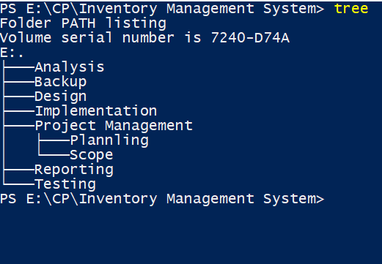

Figure : Configuration management

**Screenshot of the project data pushed on GitHub.**

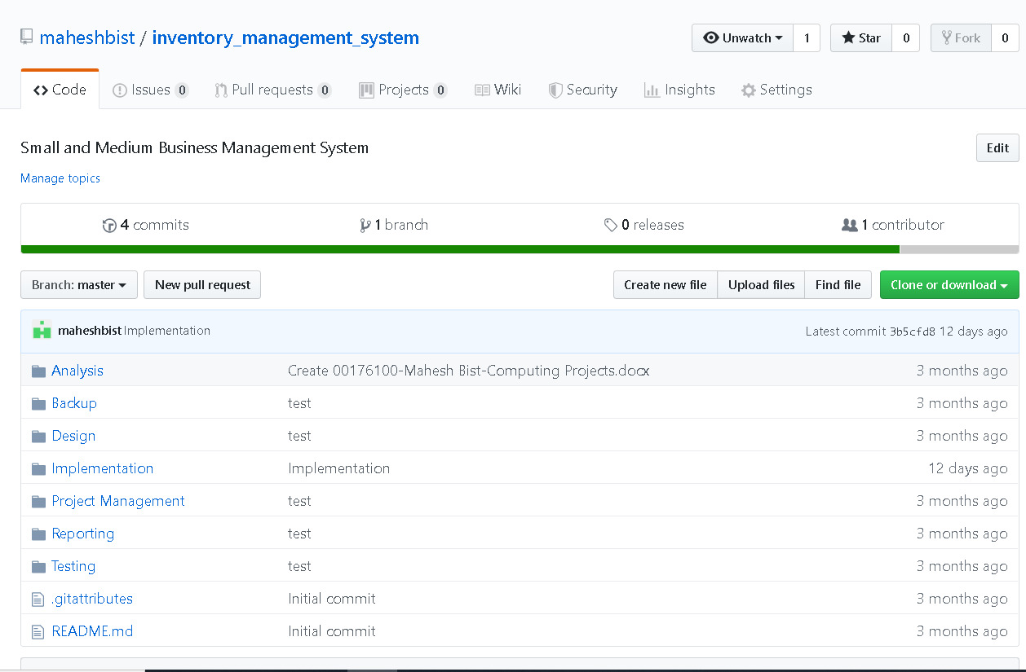

## User manual

All contain inside the user manual describe every process about how the user can access it. It is all about the system description with its every function. User manual help new user about to enter inside the system.

Login page with username and password “mahesh”

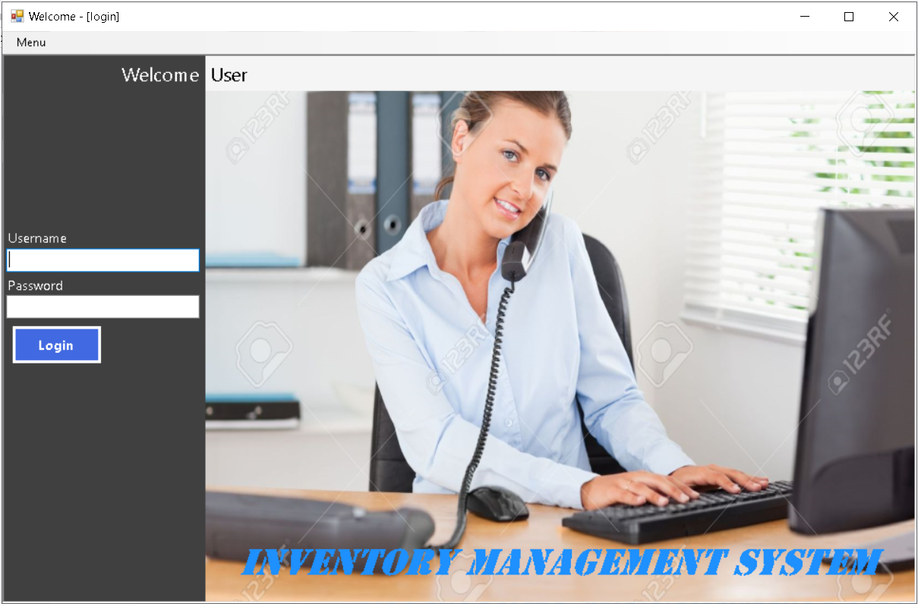

Open the system and login with your username and password.

Figure : Login Interface

Home Screen

After login the user will enter in home screen. Through home screen the user can add, edit, view, and delete the added data.

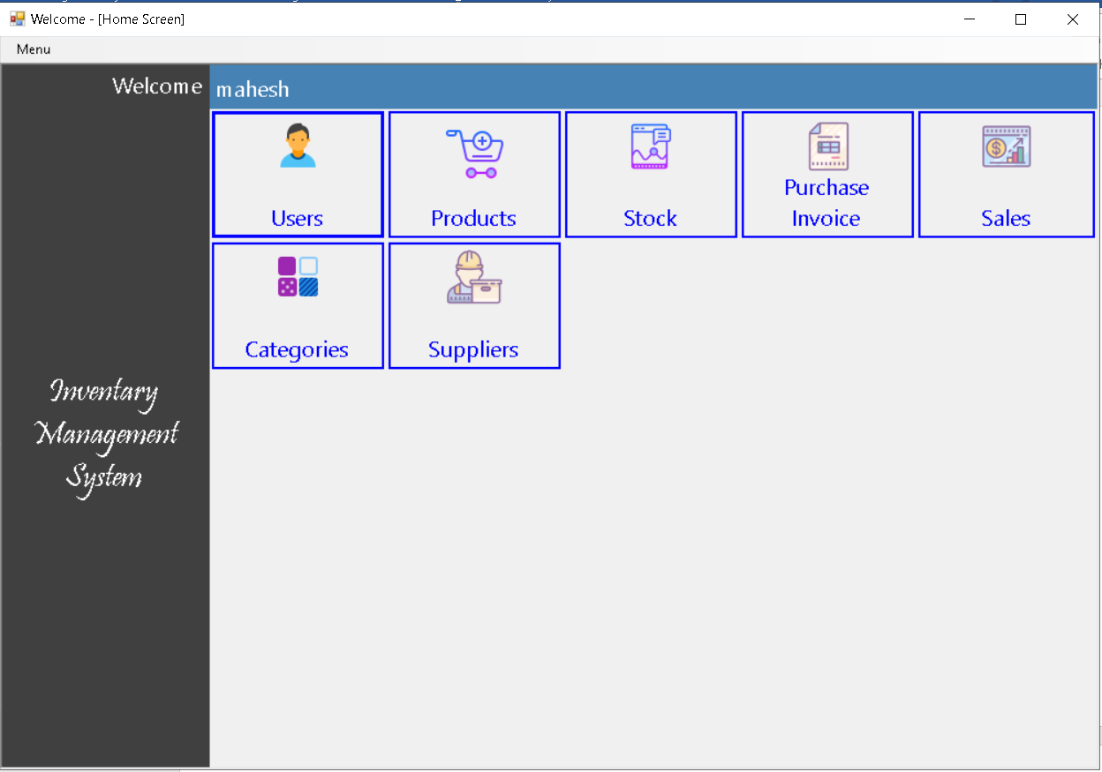

Click in user to add, edit, Delete, User and view all the data.

Figure : Home screen

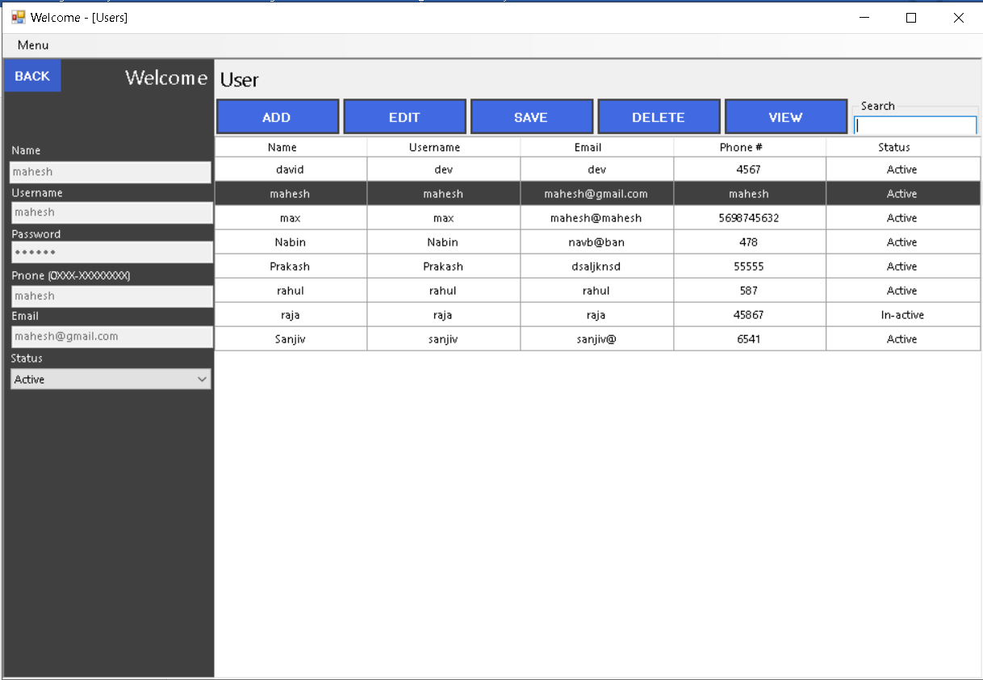

You can enter data over here to add, edit, view, etc.

Figure : User screen

In the same way you can go with another option that are inside the home screen.

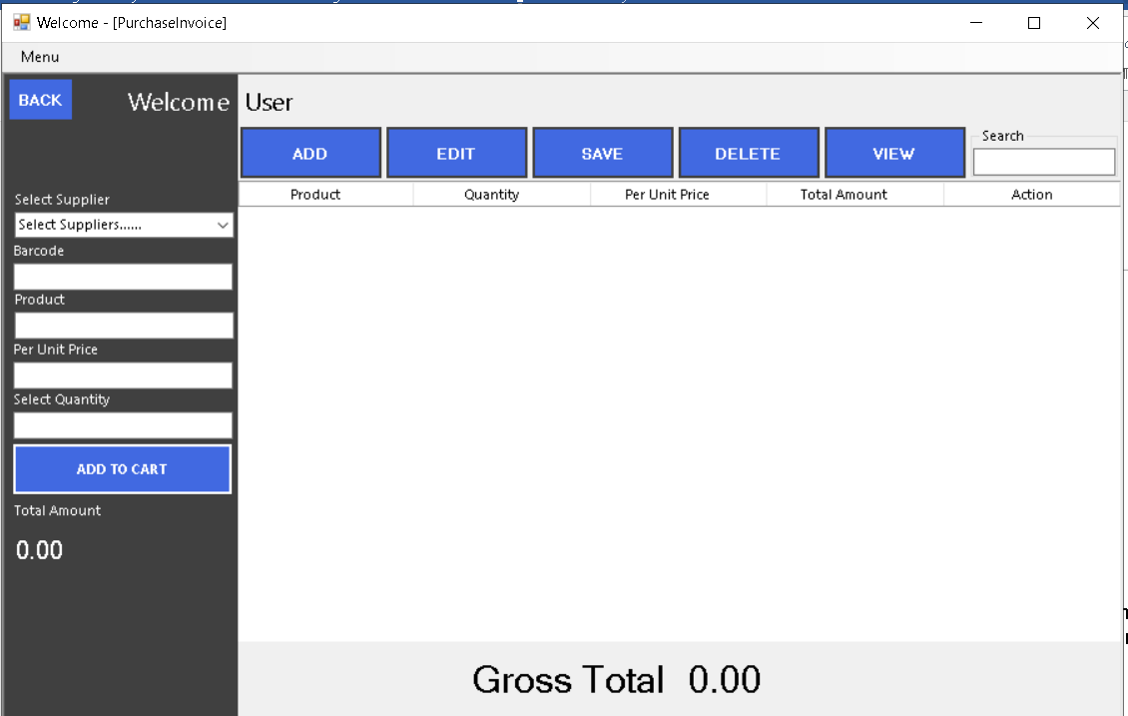

Enter data as well as existed barcode and click on the button Add to Cart to view all product Invoice.

Figure : Purchase Invoice

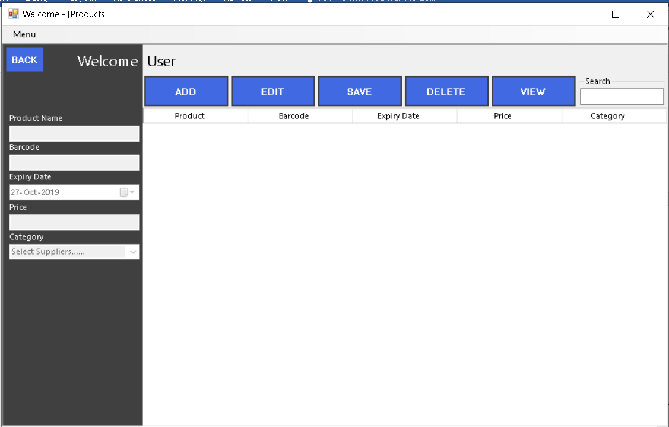

Figure : Product screen

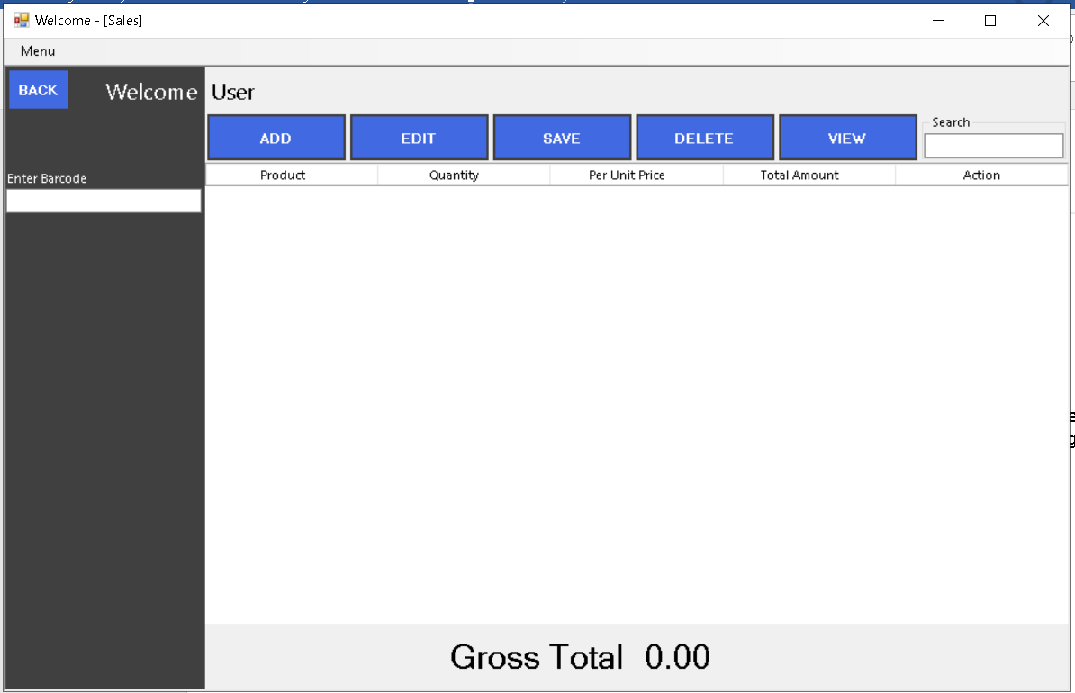

You need barcode of the product to view the sale of the warehouse.

Figure : Sales Screen

This is the Screen through which you also will be able to connect the database in case of using application on other desktop. To connect SQL server, click Menu and then choose Setting and click on it.

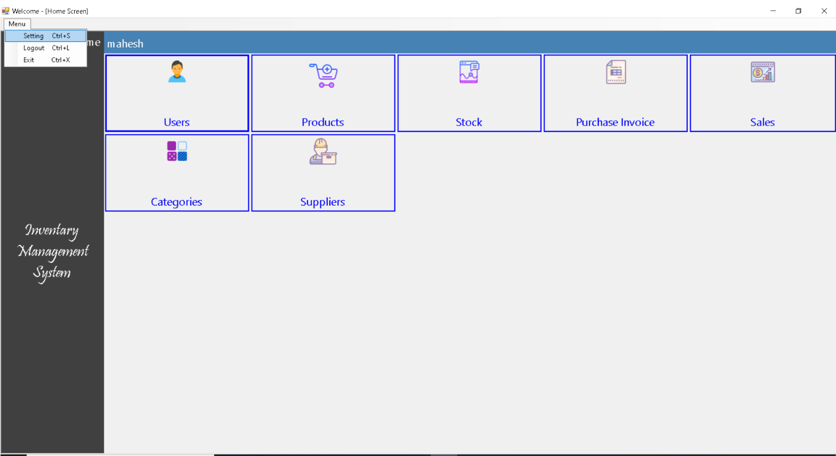

To Logout click on logout.

Click on Menu and then click on Setting. After click on setting you will get the screen of setting.

After Click on setting this screen will open.

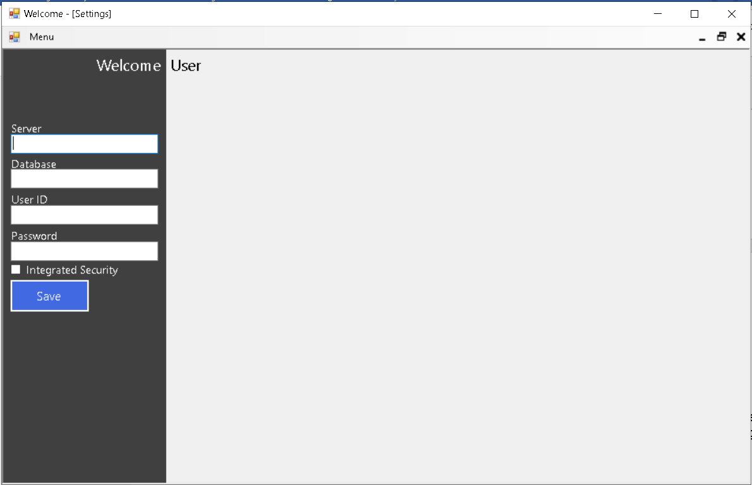

Figure : Database Connector

# Conclusion

I conclude an inventory management system is a system designed to help businesses automate their inventory management, whether the inventory is the company’s assets or merchandise.

The development of the project is done under waterfall approach. First the analysis about the project is done to find advantage, disadvantage, and risk with its risk management, after its analysis the design of the project is done in certain date, Then Implementation with its Database design as well as GUI design is done and then finally the Testing part got completed.

# References

apploy, 2016. *www.smartdraw.com.* [Online]   
Available at: https://www.smartdraw.com/use-case-diagram

Dale, 2017. *www.techopedia.com.* [Online]   
Available at: https://www.techopedia.com/definition/24649/three-tier-architecture

Farooq, U., 2016. *www.businessstudynotes.com.* [Online]   
Available at: https://www.businessstudynotes.com/finance/project-management/types-feasibility-study/

Gary Afable, 2010. *www.smartdraw.com.* [Online]   
Available at: https://www.smartdraw.com/sequence-diagram/#whatisSequenceDiagram

Ivory-Ndiaye, M. Y., 2013. *www.visual-paradigm.com.* [Online]   
Available at: https://www.visual-paradigm.com/guide/uml-unified-modeling-language/what-is-activity-diagram/

jira, 2010. *www.smartdraw.com.* [Online]   
Available at: https://www.smartdraw.com/data-flow-diagram/#DFDSymbols

karamer, 2014. *www.businessdictionary.com.* [Online]   
Available at: http://www.businessdictionary.com/definition/analysis.html

Krüger, N., 2018. *www.perforce.com.* [Online]   
Available at: https://www.perforce.com/blog/alm/how-write-software-requirements-specification-srs-document

mandon, j., 1998. *www.wrike.com.* [Online]   
Available at: 1. https://www.wrike.com/project-management-guide/faq/what-is-configuration-management-in-project-management/

manir, r., n.d. *www.twi-global.com.* [Online]   
Available at: https://www.twi-global.com/technical-knowledge/faqs/what-is-the-hard-systems-approach-to-problem-solving  
[Accessed 2013].

toyee, G., 2010. *www.smartdraw.com.* [Online]   
Available at: https://www.smartdraw.com/entity-relationship-diagram/#whatIsERD

# Appendix:

**All the Screenshot UI design with their particular code.**

Login page with username “mahesh” and password “mahesh”.



Figure : Login interface.

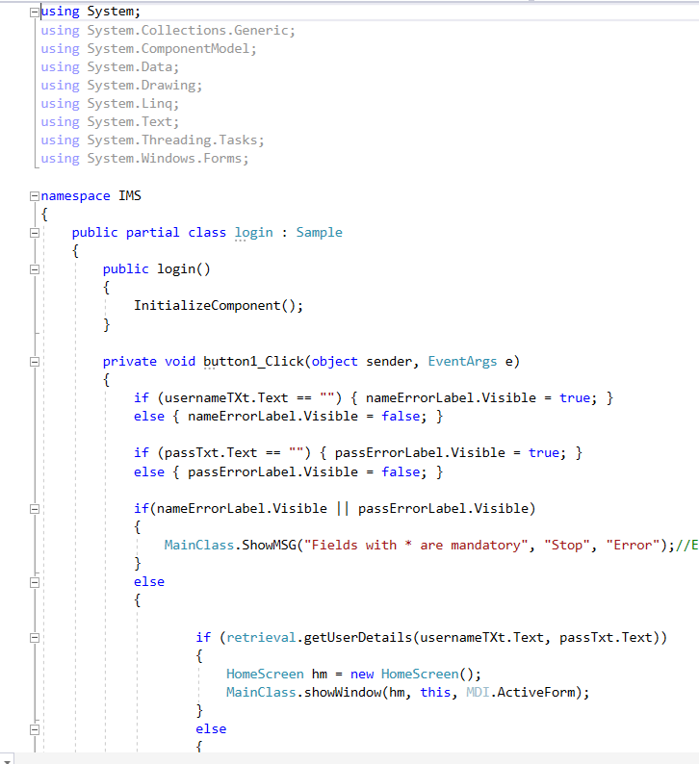

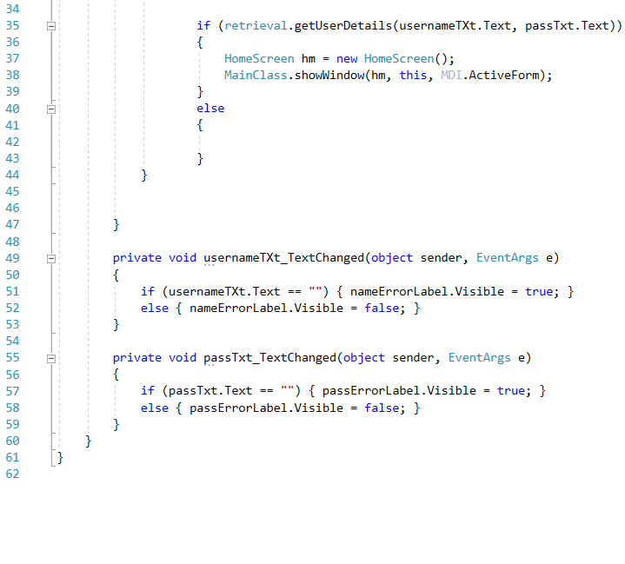

**Home Screen**



Figure : Home screen

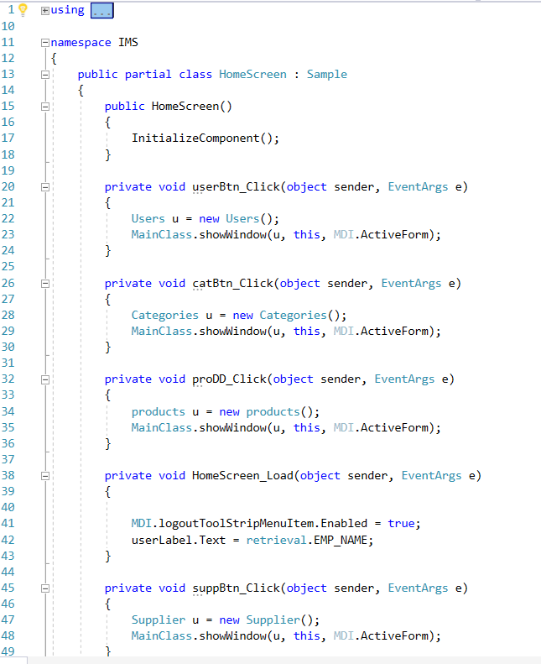

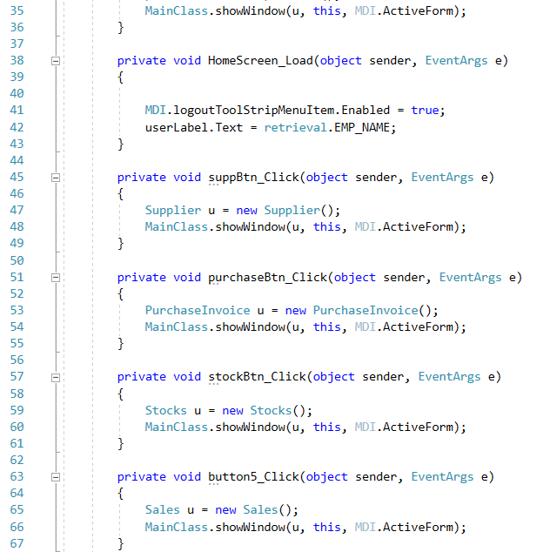

User Interface



Figure : User screen

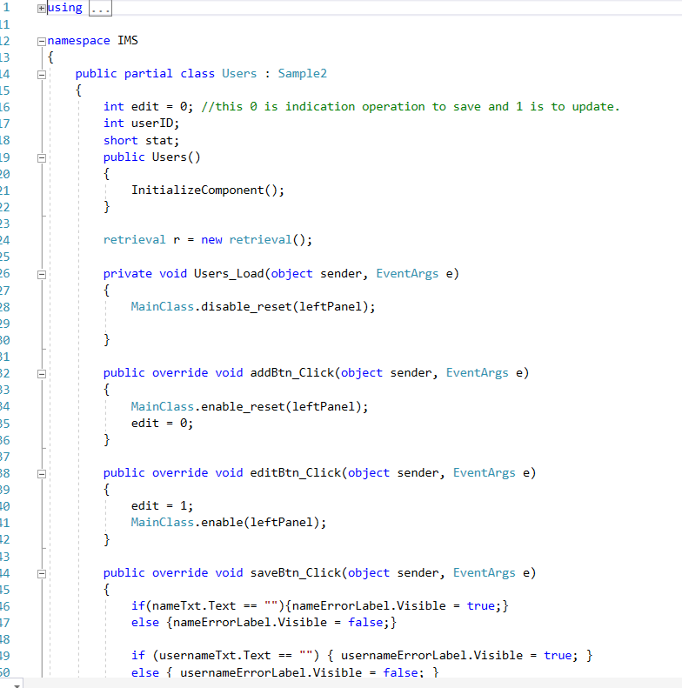

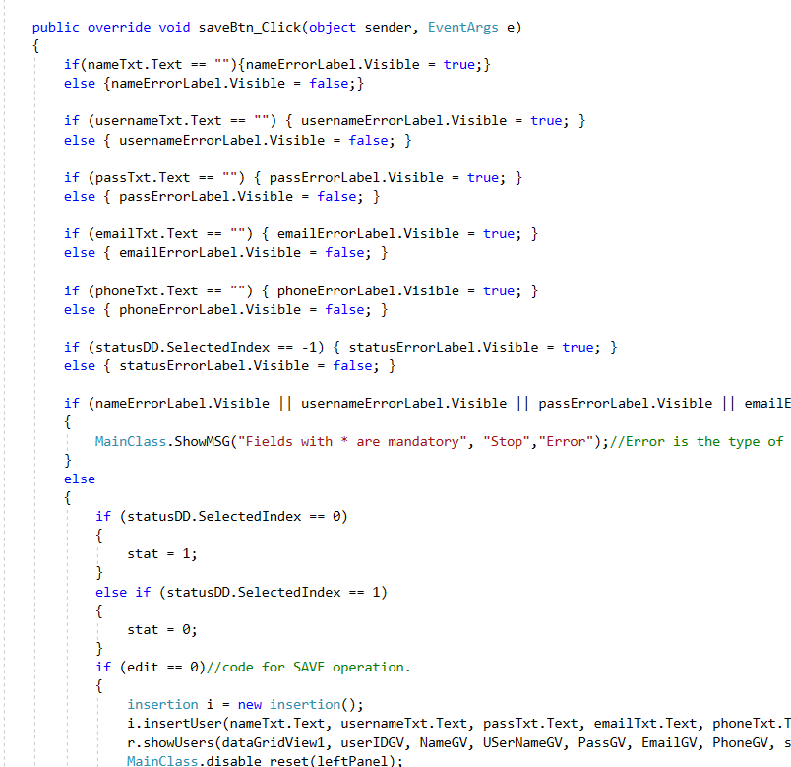

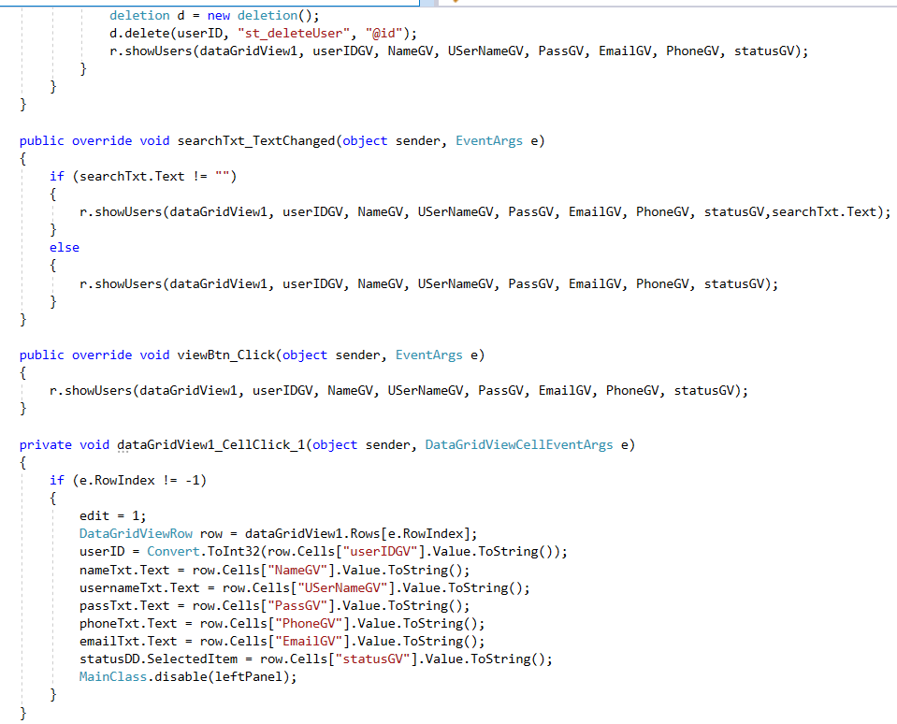

**Purchase Invoice Interface**



Figure : Purchase Invoice

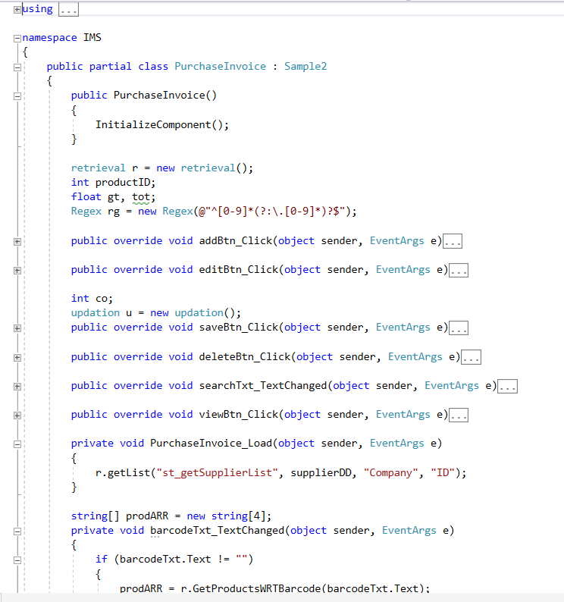

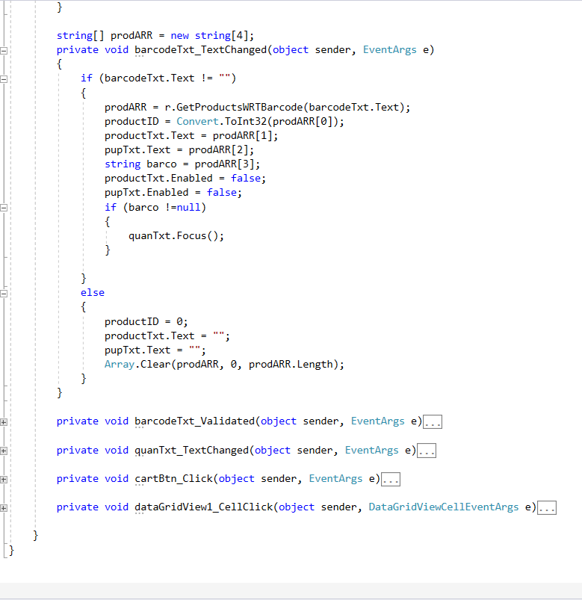

Product Interface with code.



Figure : Product screen

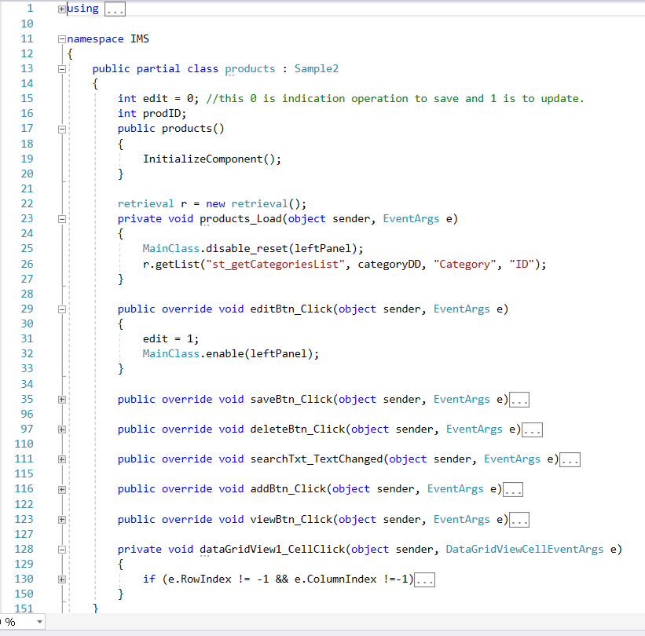

Sales Interface with Code



Figure : Sales Screen

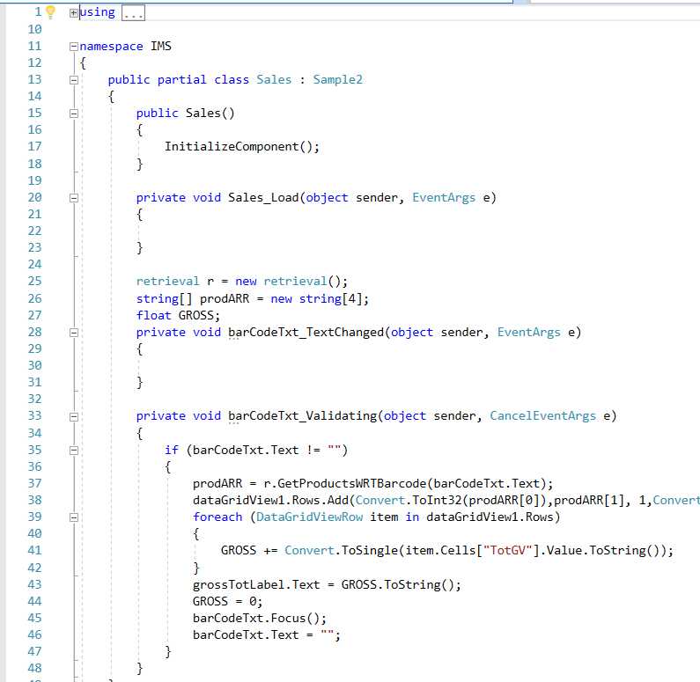

Setting Interface with code



Figure : Database Connector

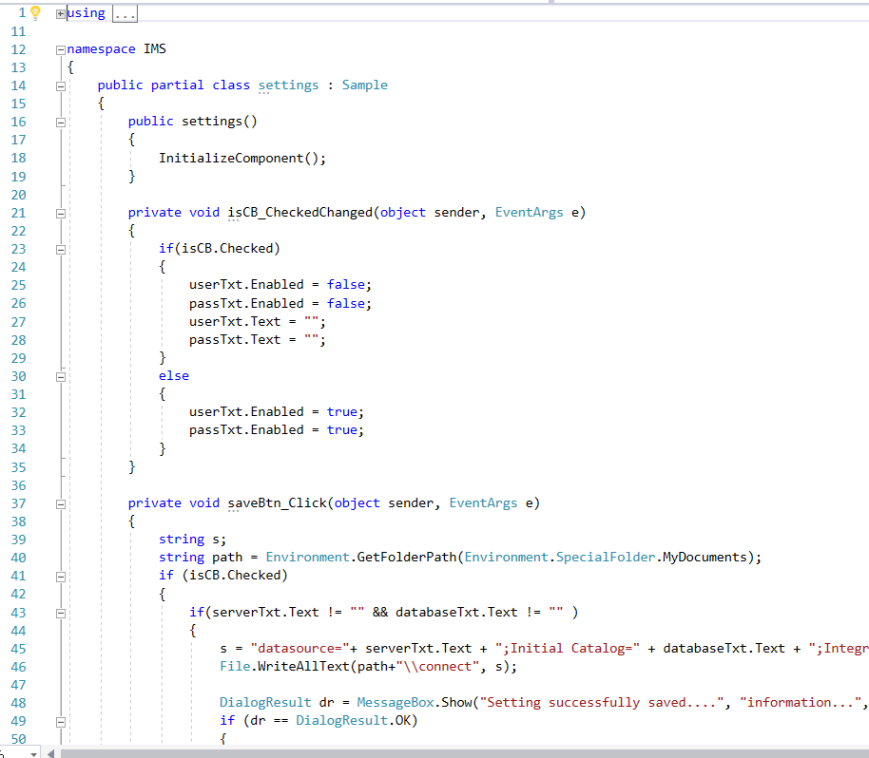

Supplier Code with interface

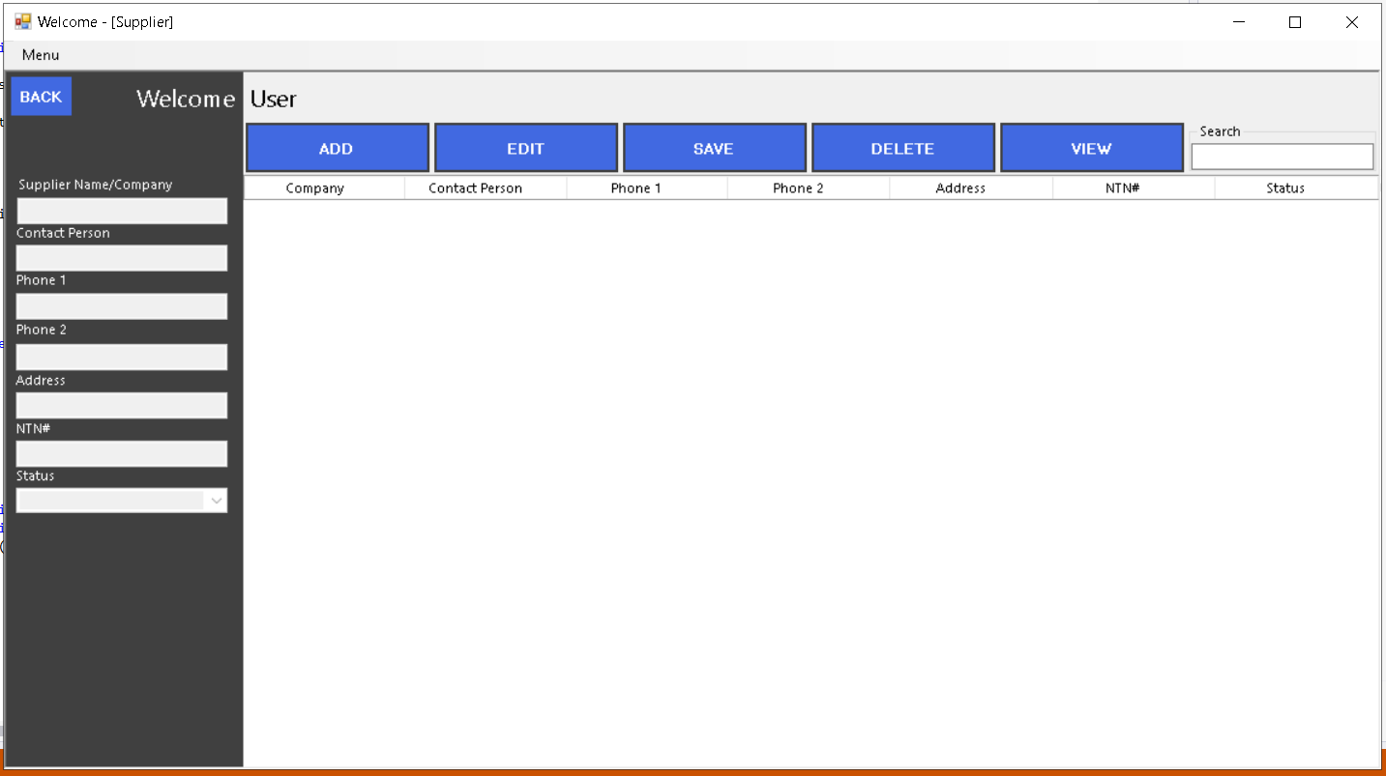

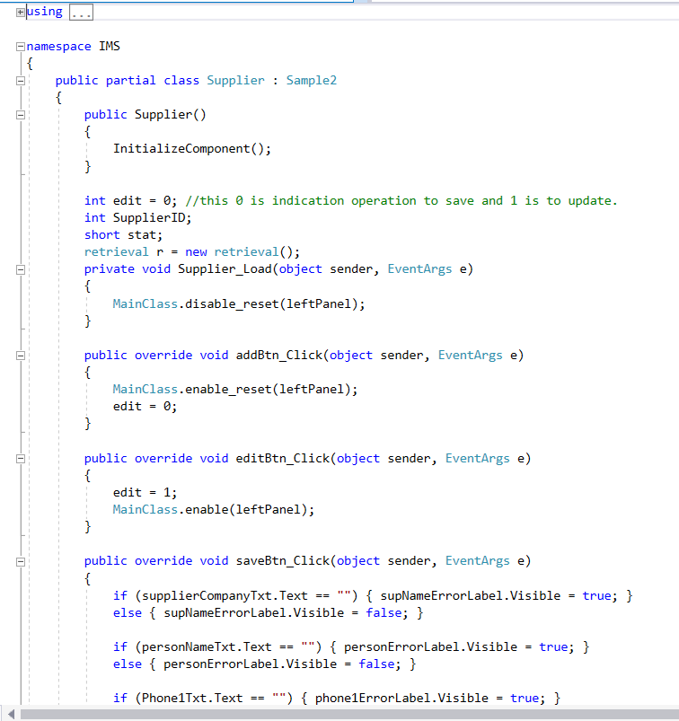

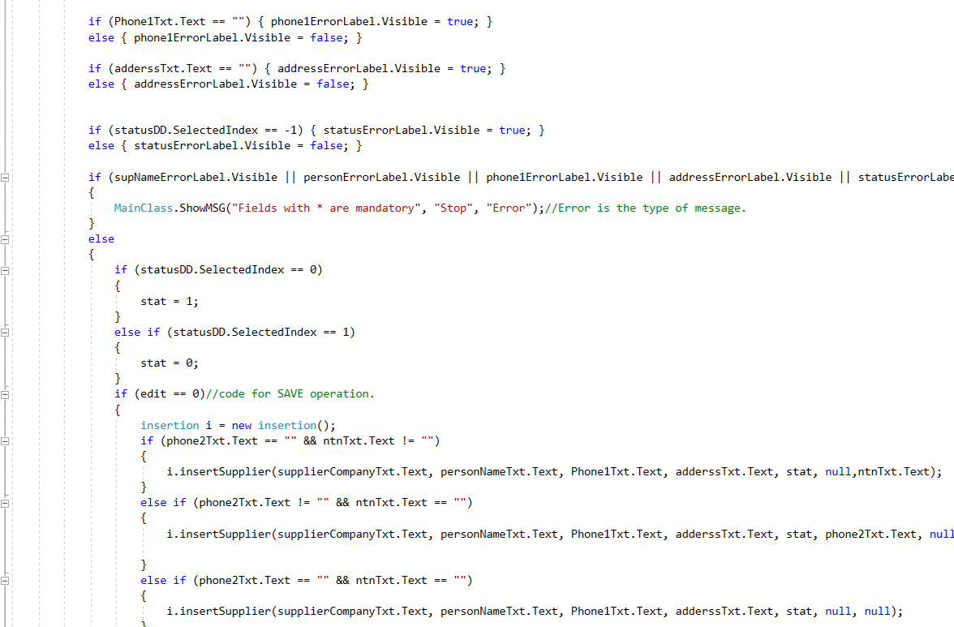

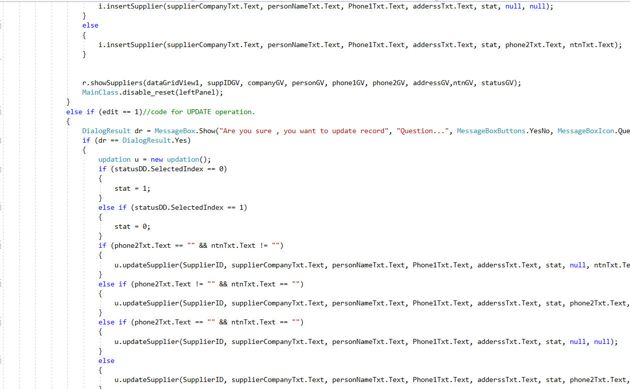

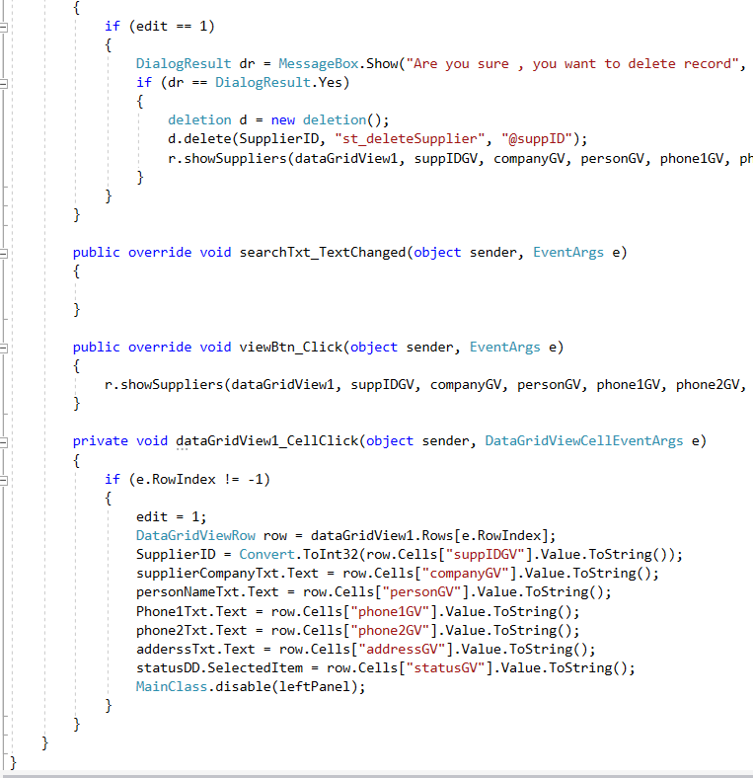

Category Interface with Code.

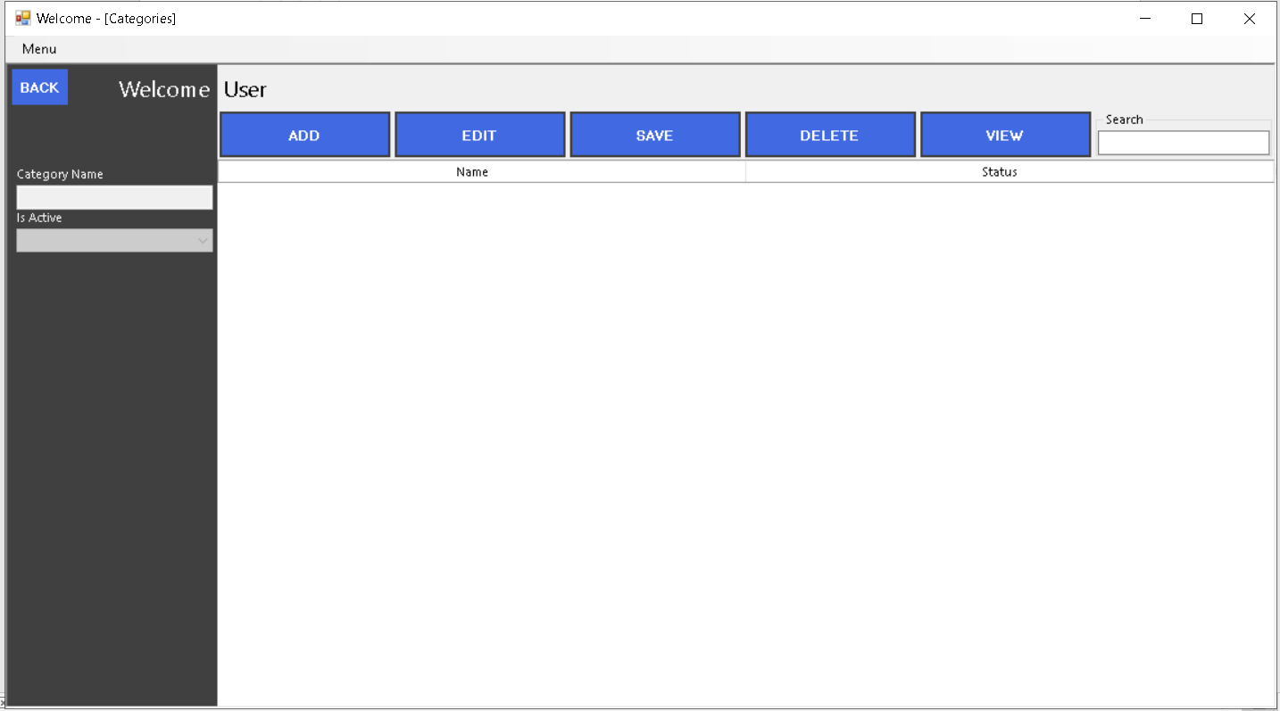

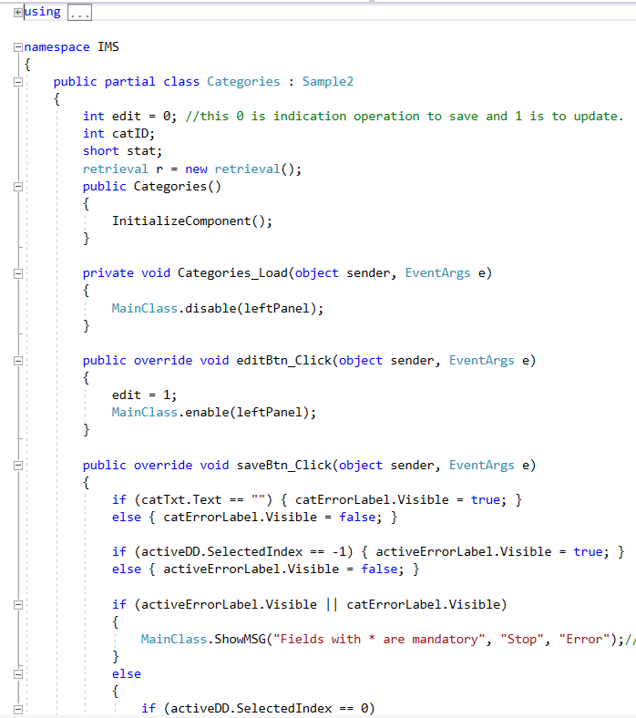

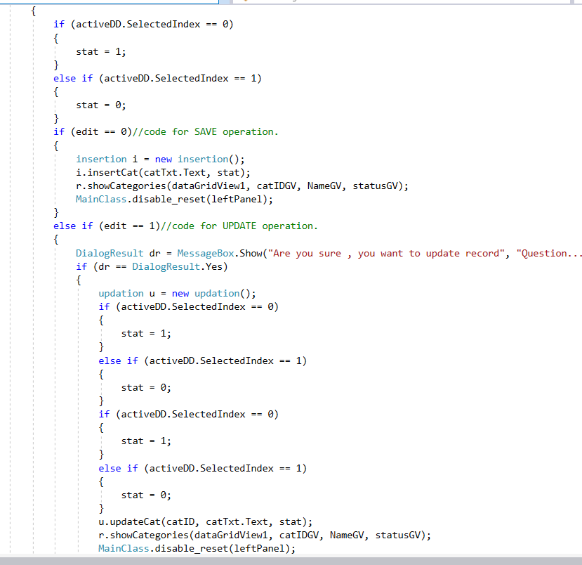

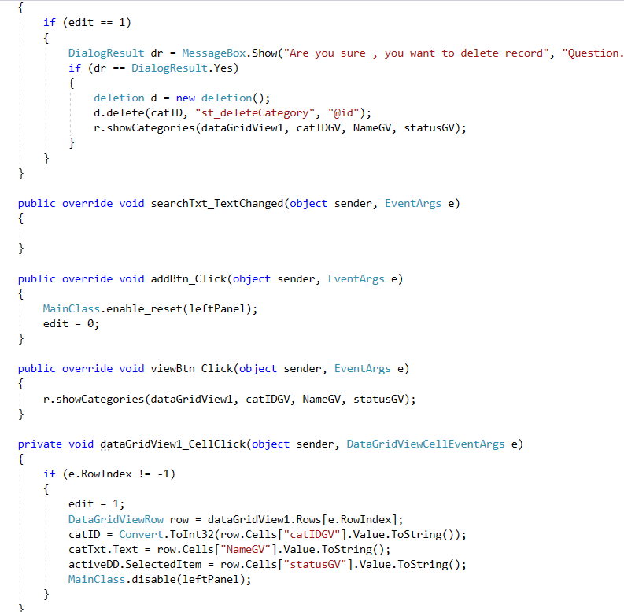

Stock Interface with Code

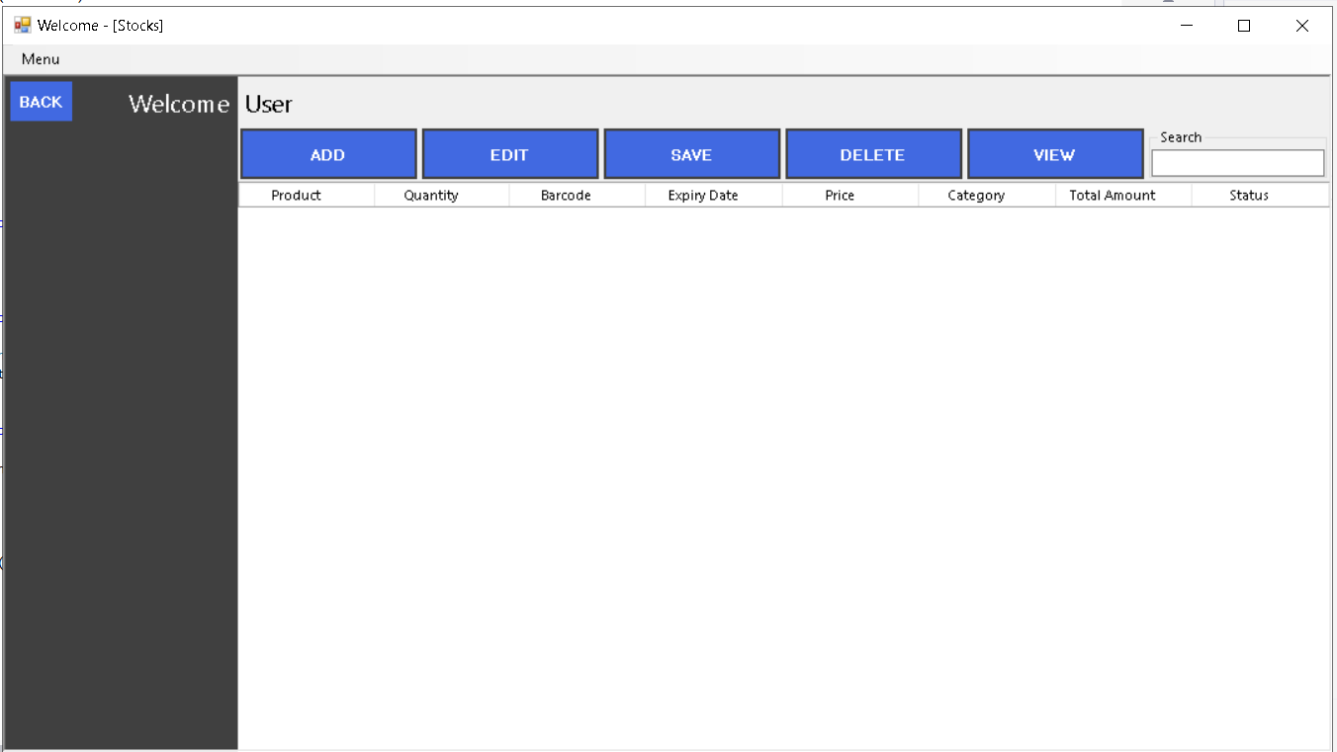

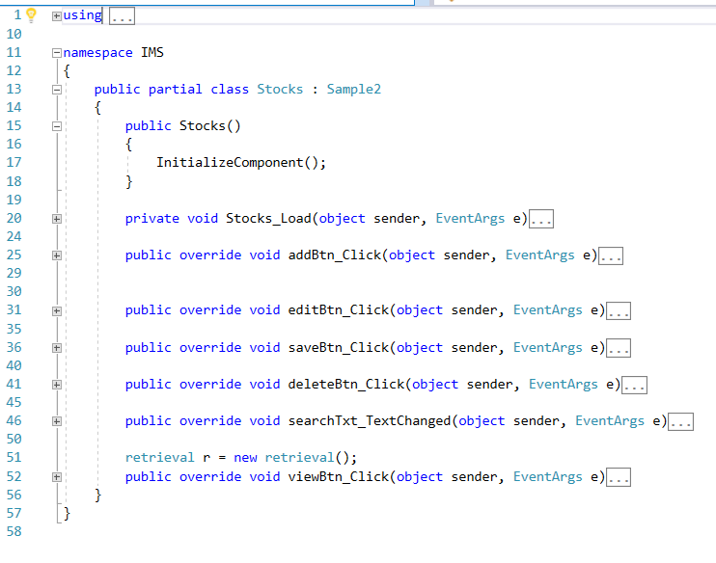

Purchase Invoice Detail

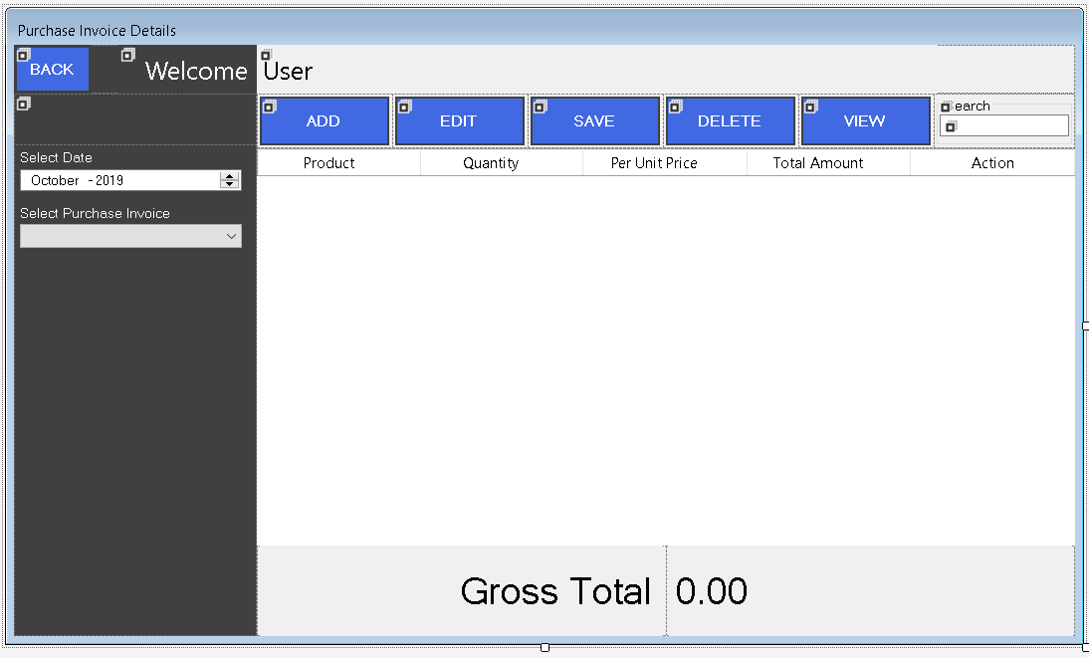

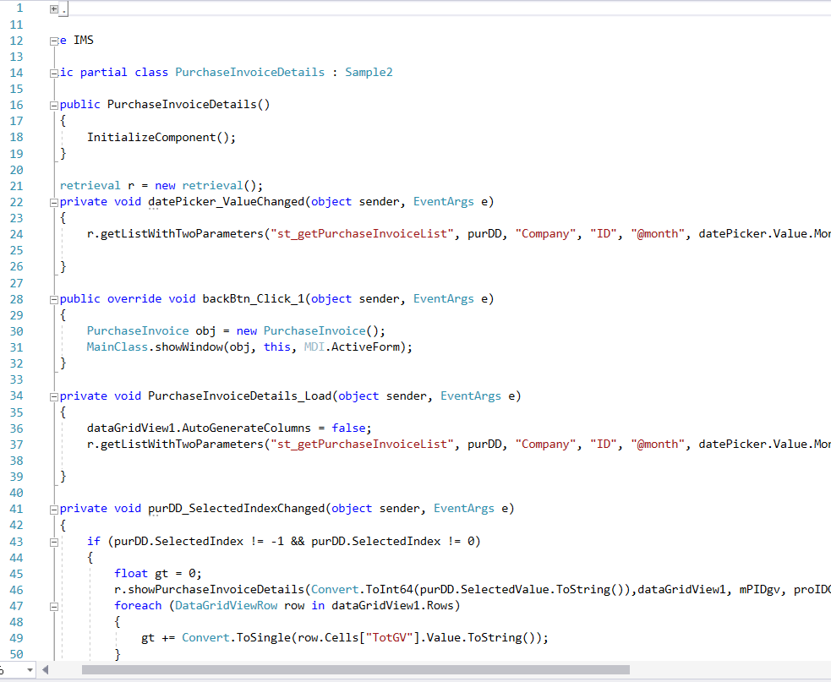

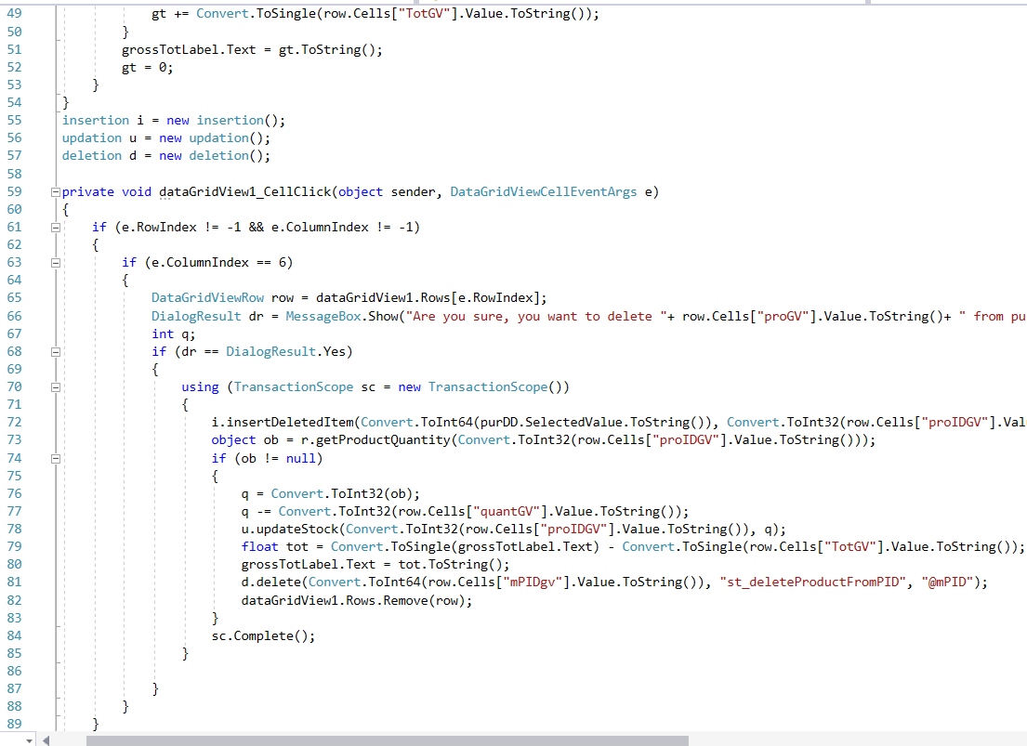

MDI Interface which is create as parent to inherit Form.

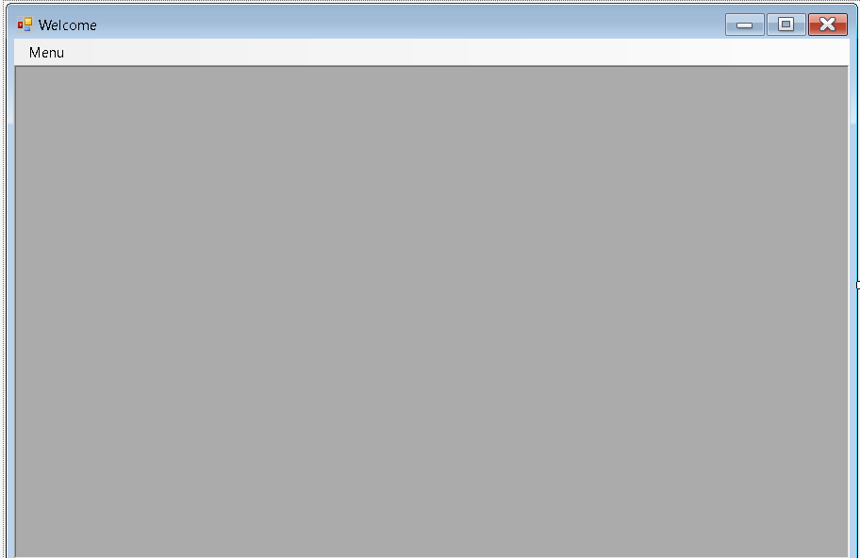

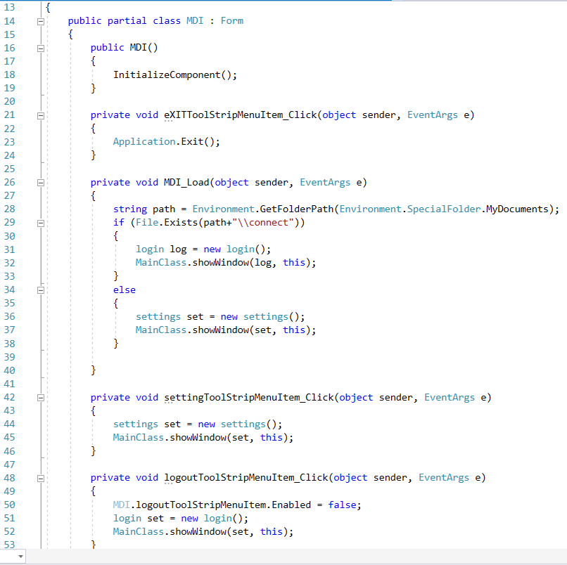

Sample Interface with code

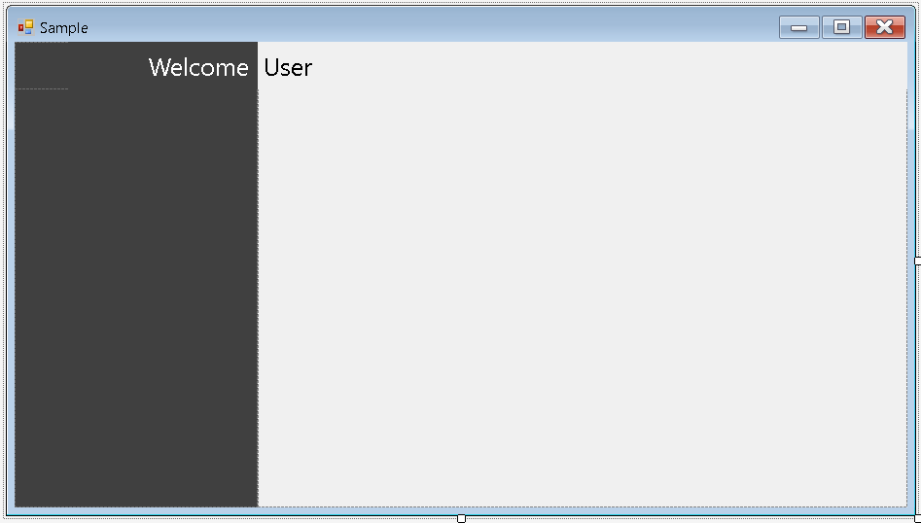

Inherit from form

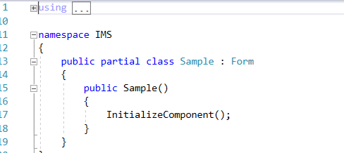

Sample 2 with code

This form is used to make other same forms like this through inheritance.

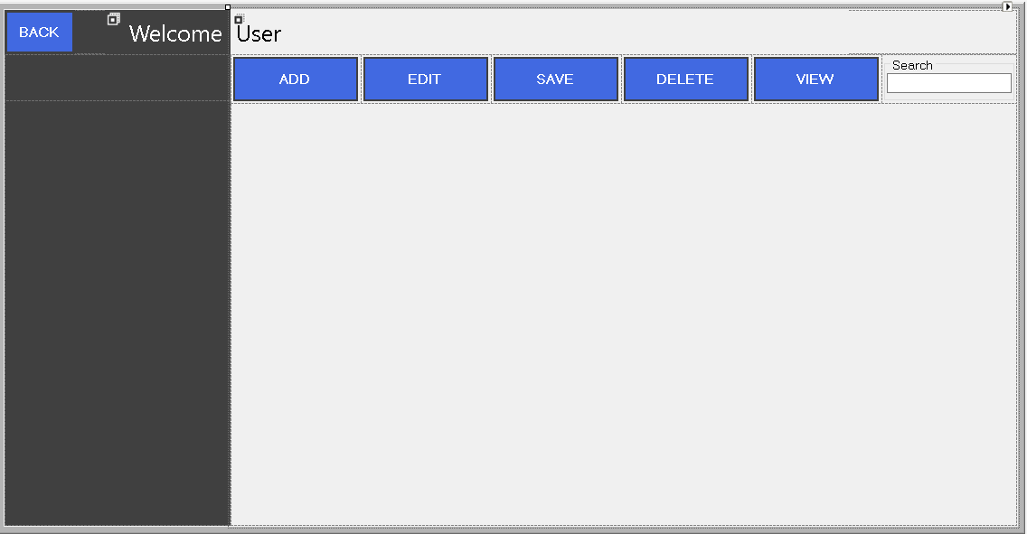

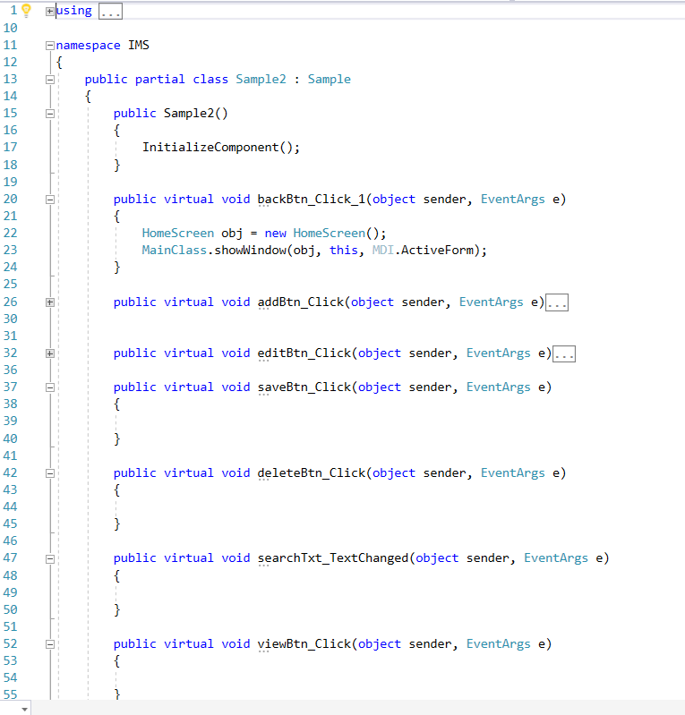

Updating class Code

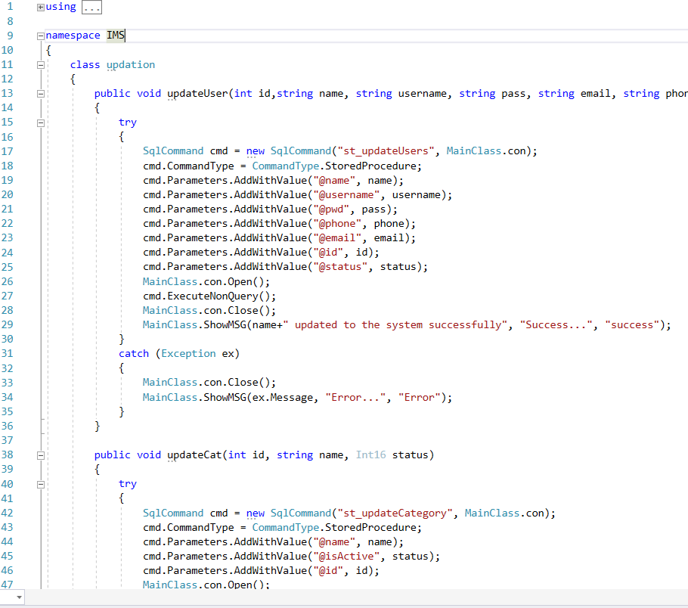

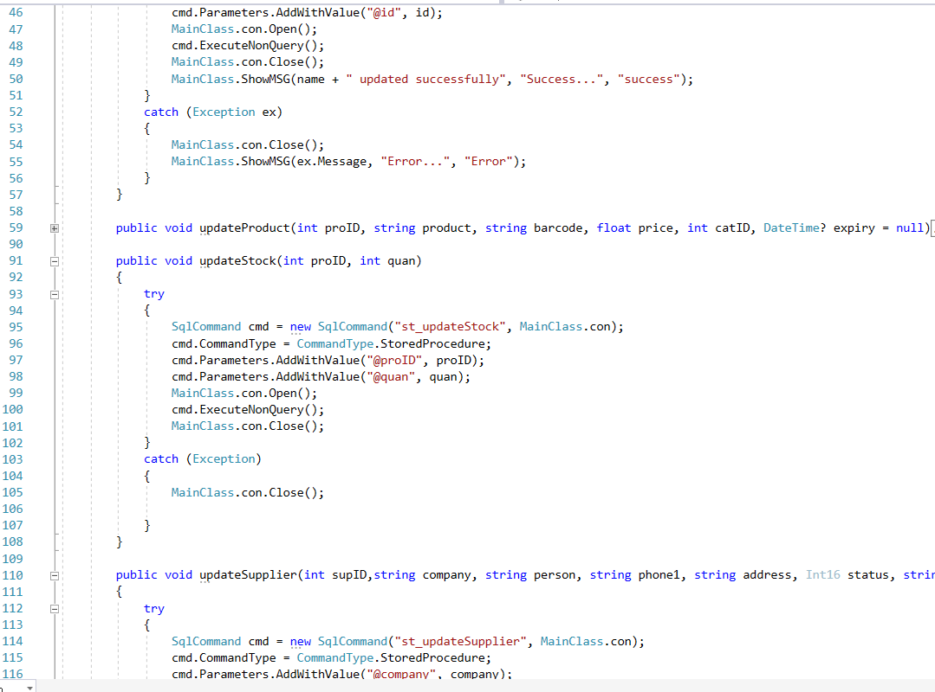

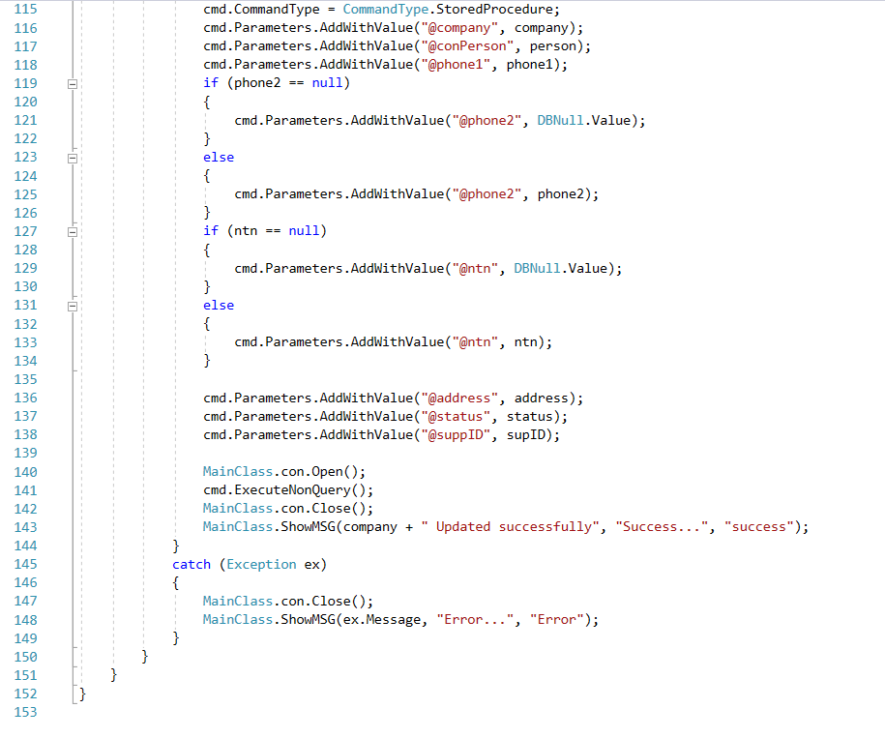

Retrieval Code

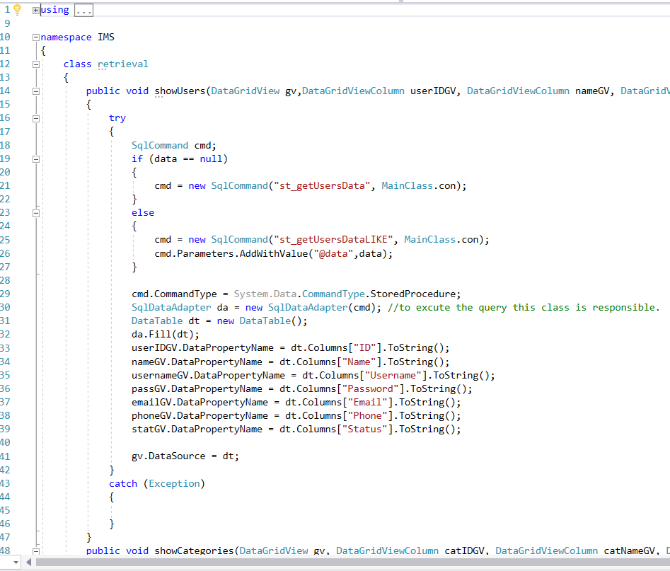

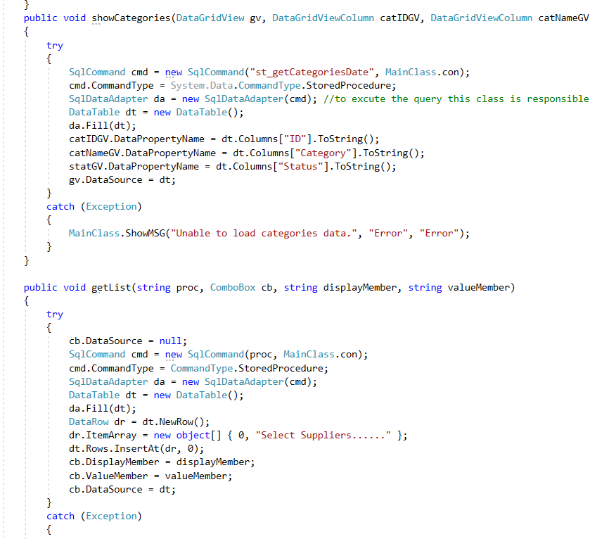

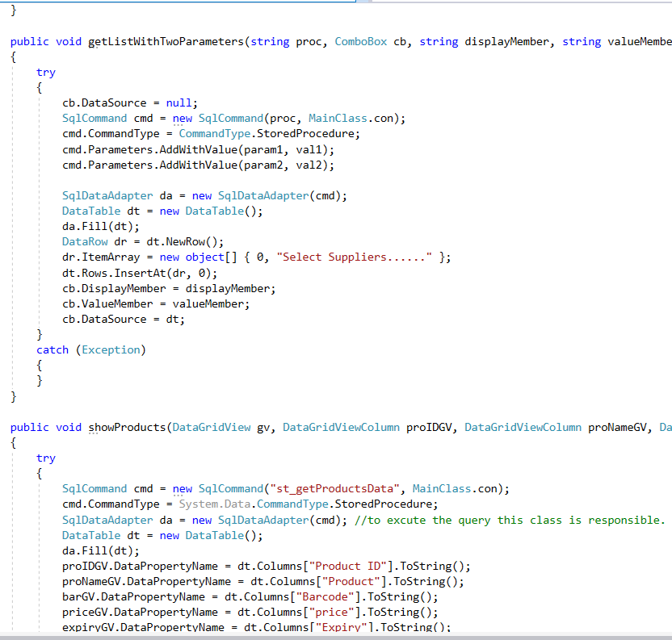

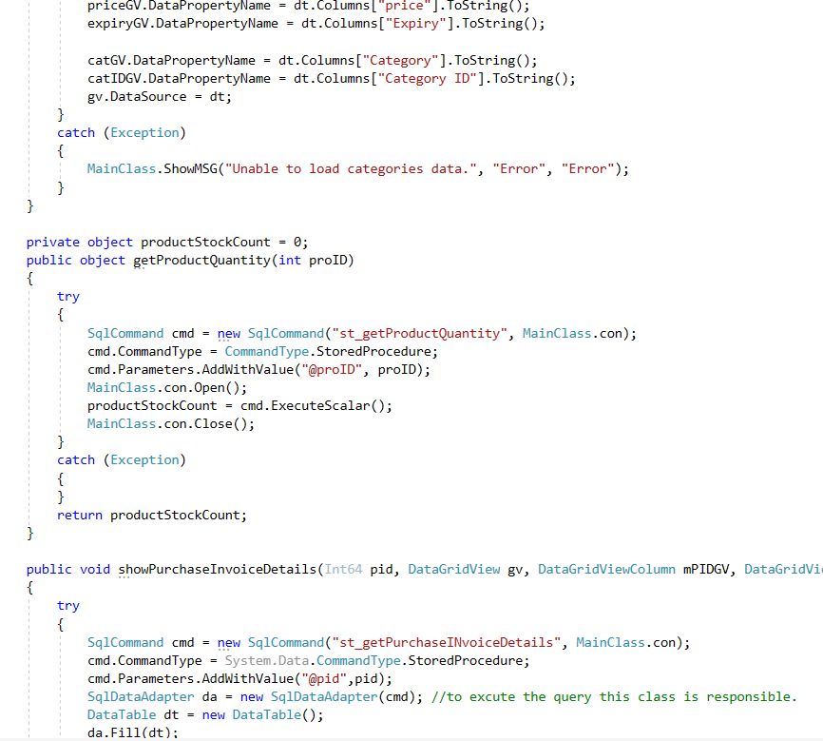

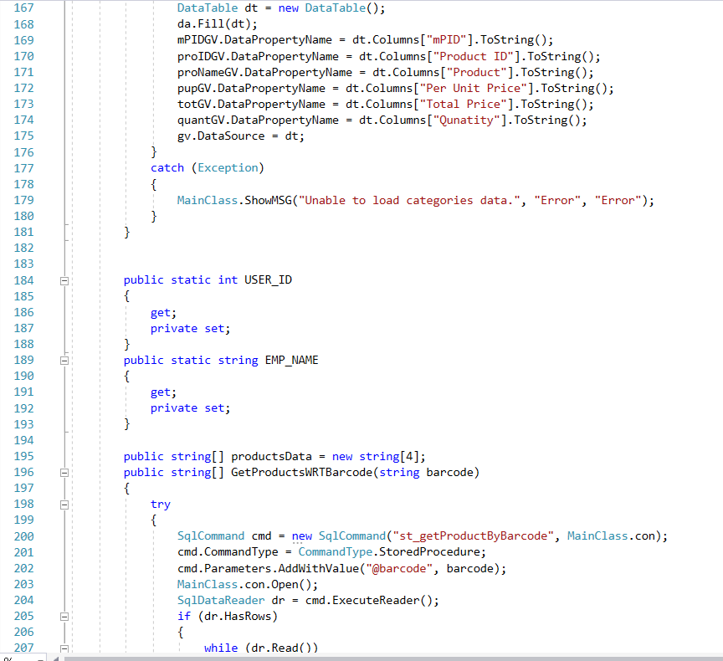

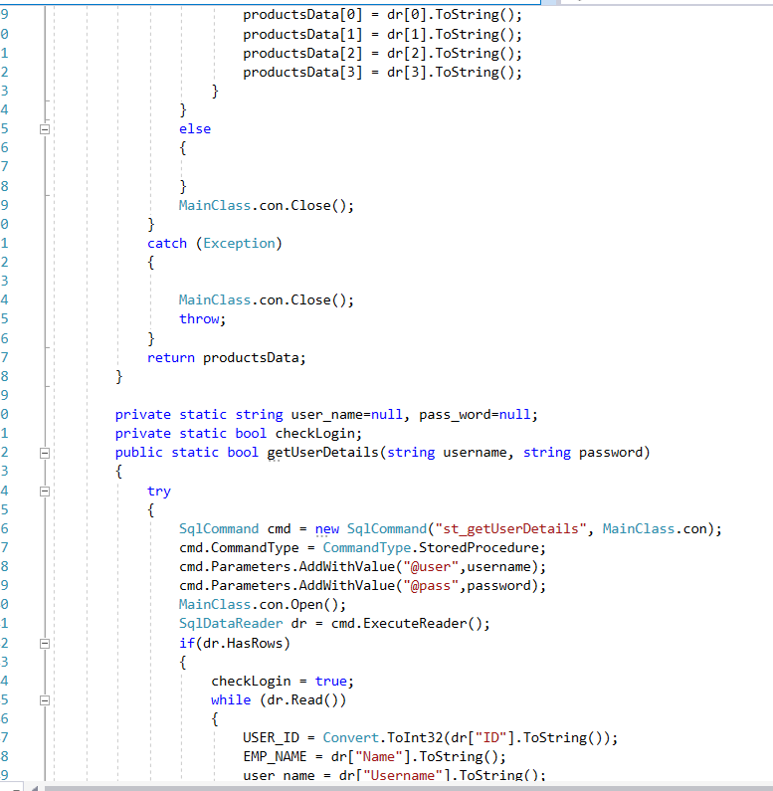

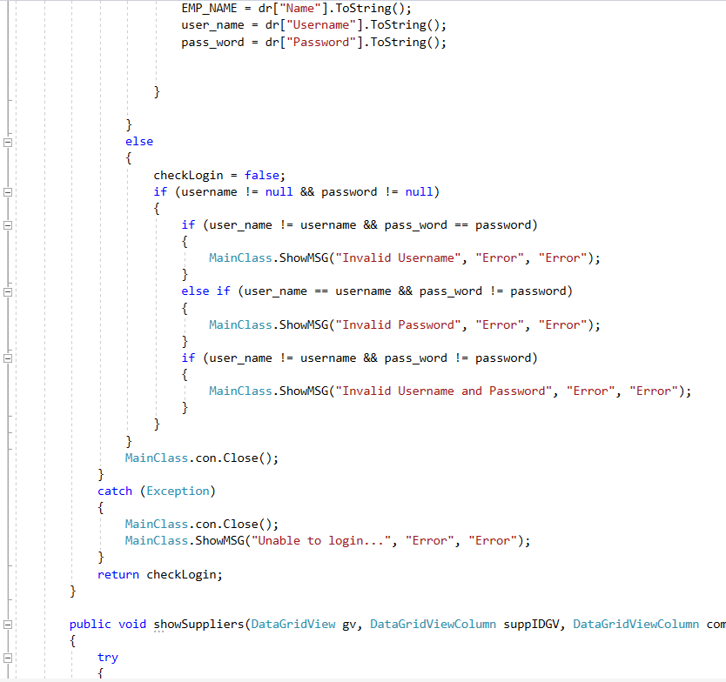

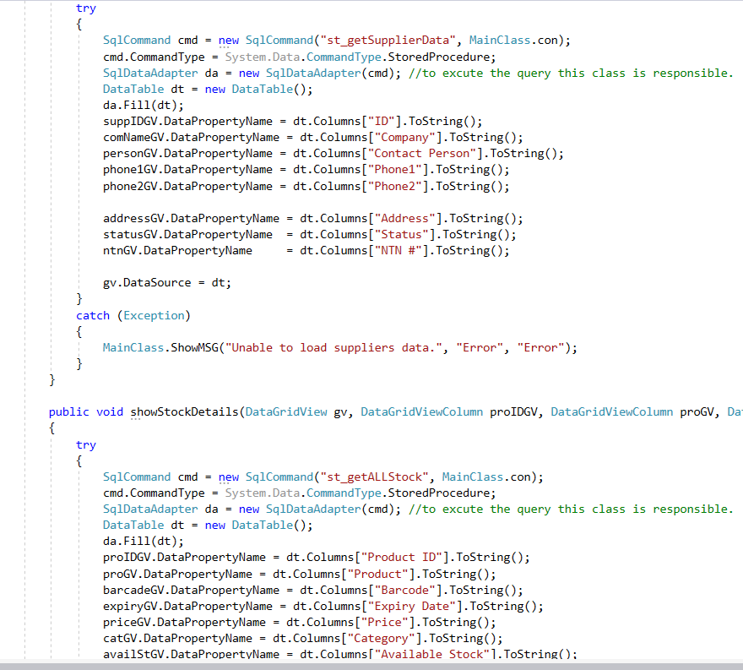

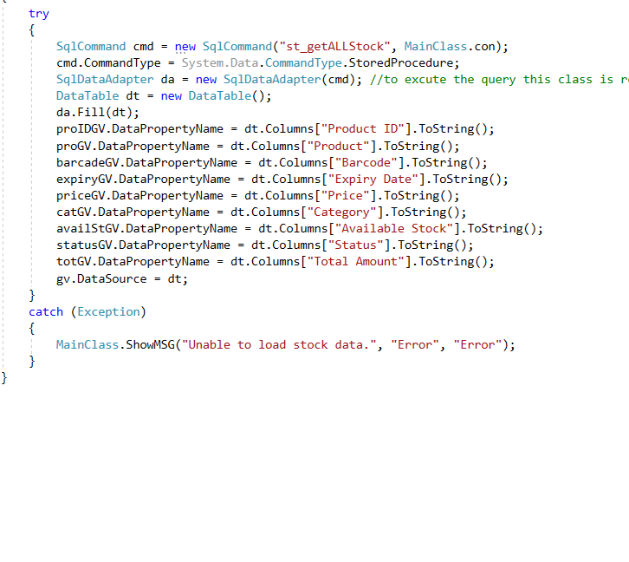

Deletion class Code

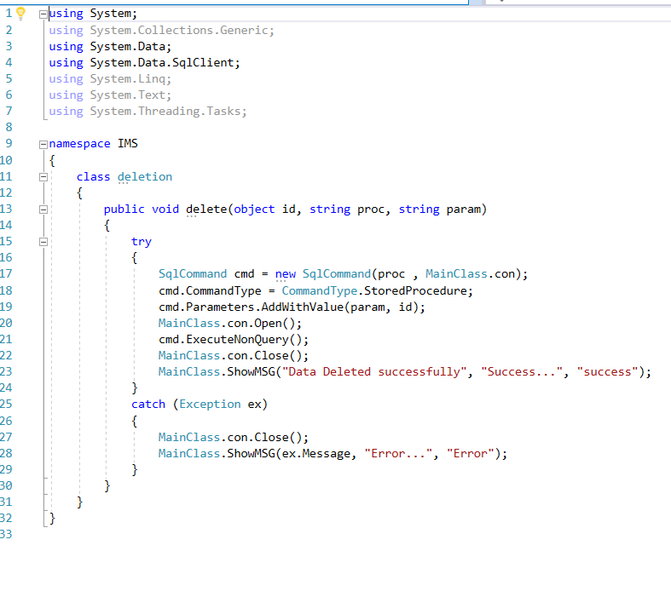

Insertion Class code

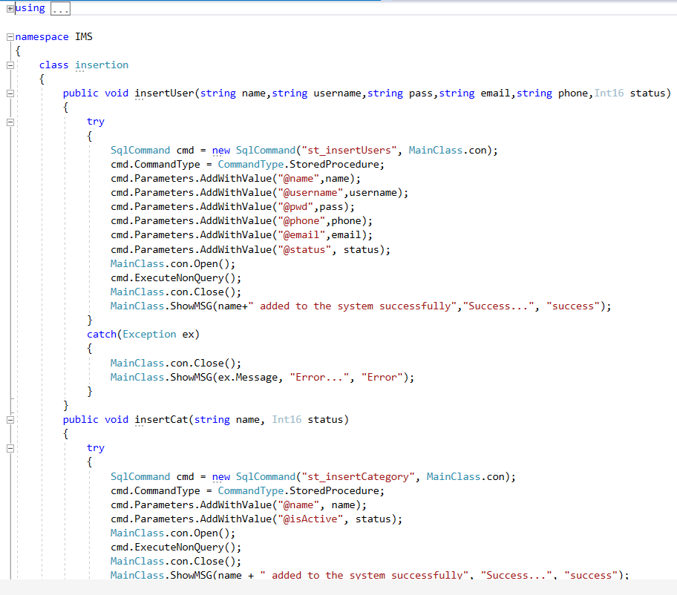

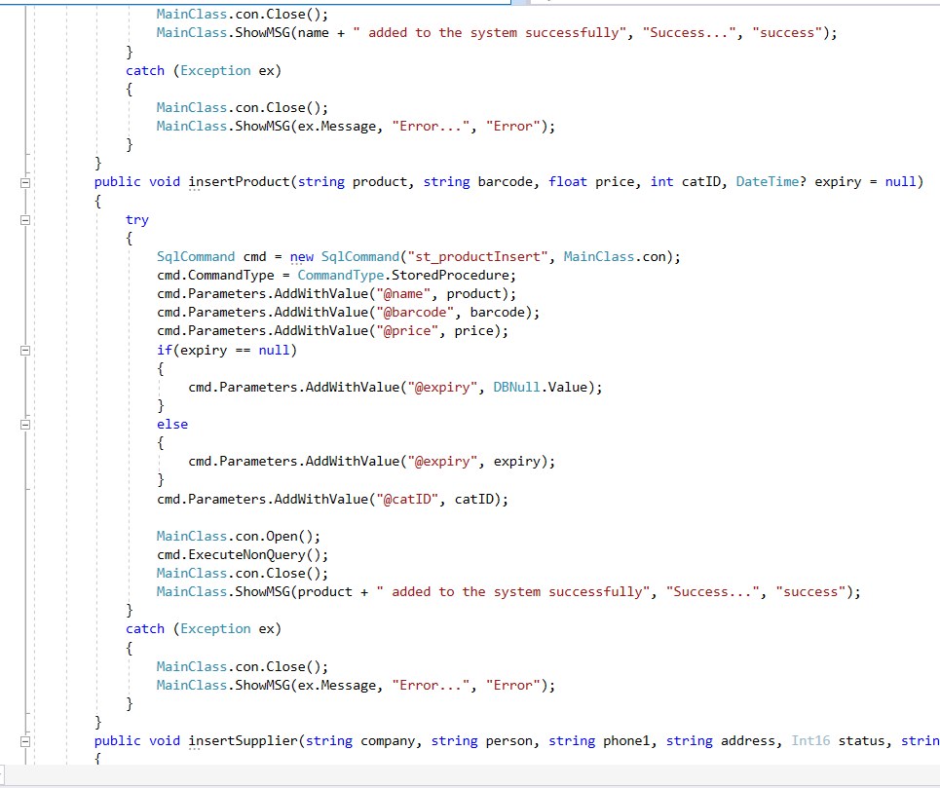

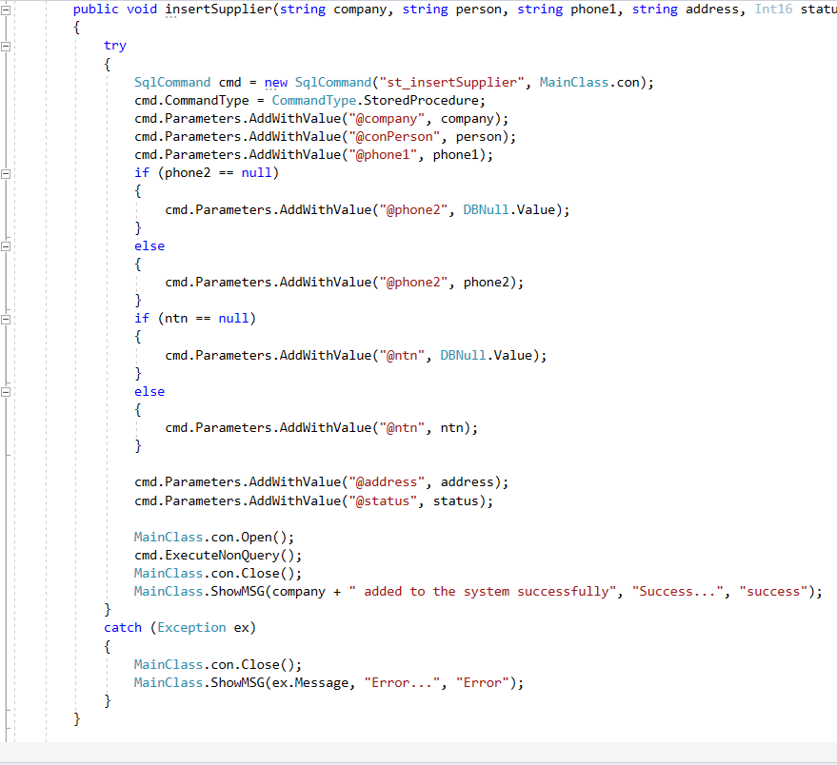

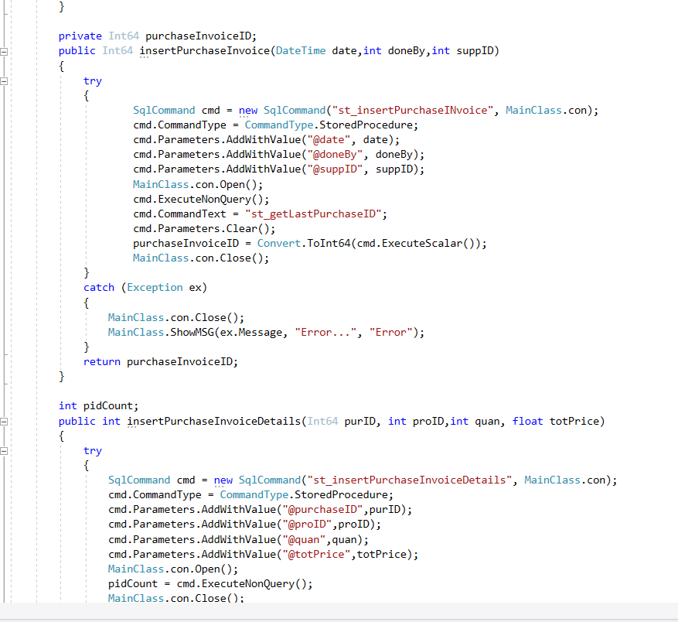

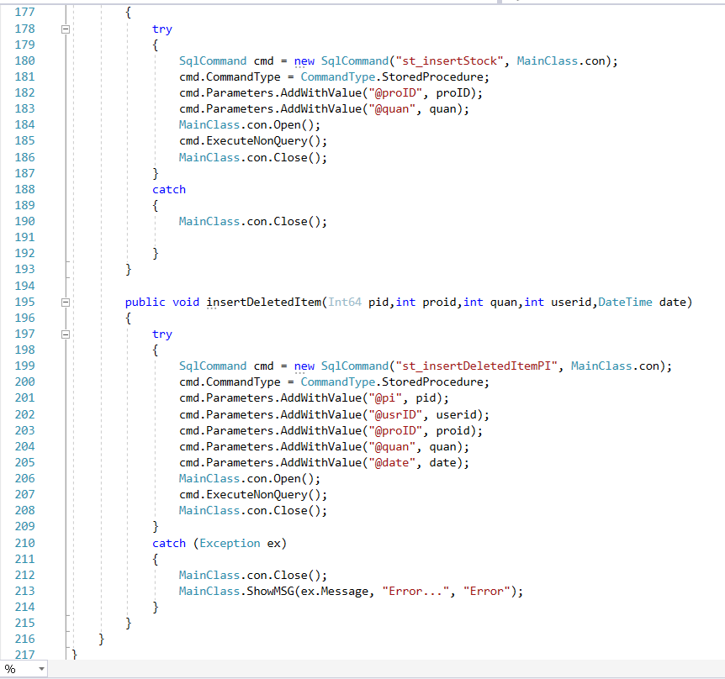

Program.cs code

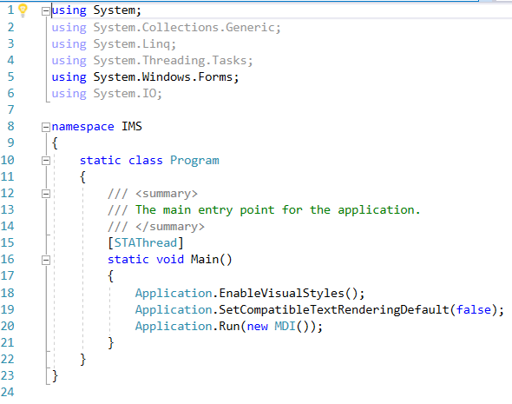

Mainclass.cs Code

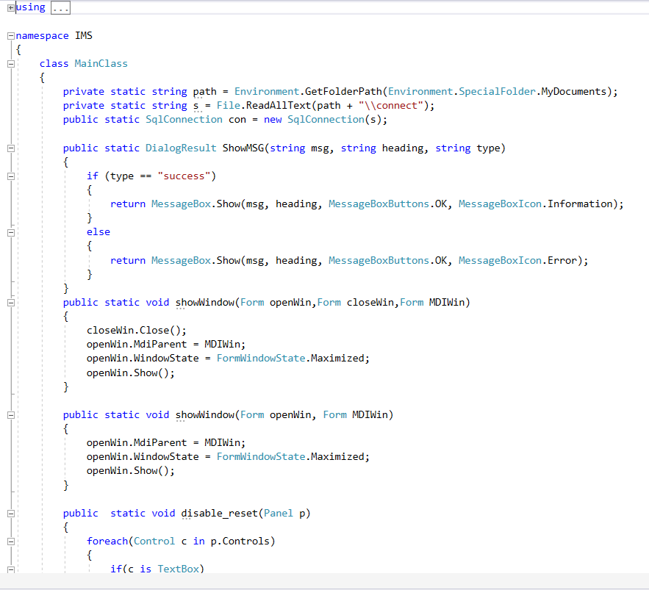

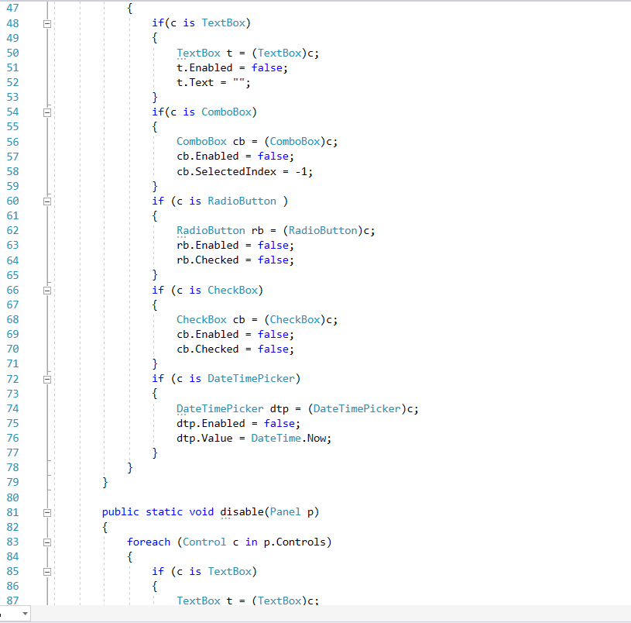

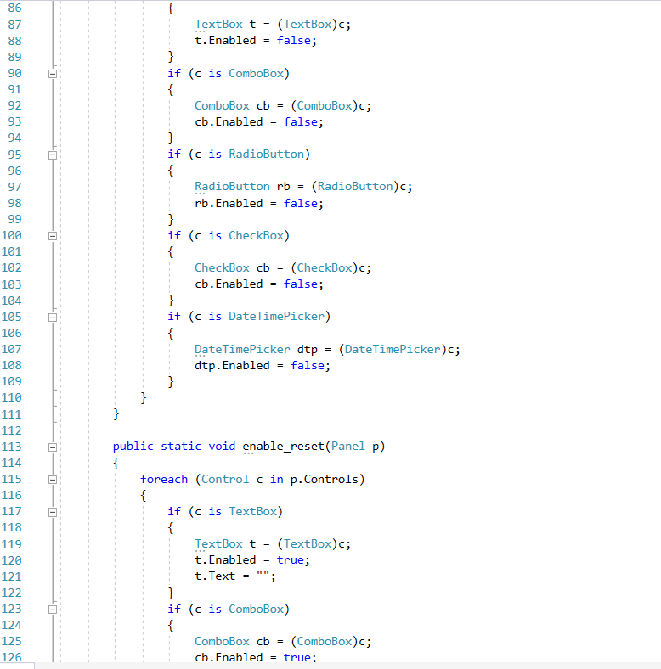

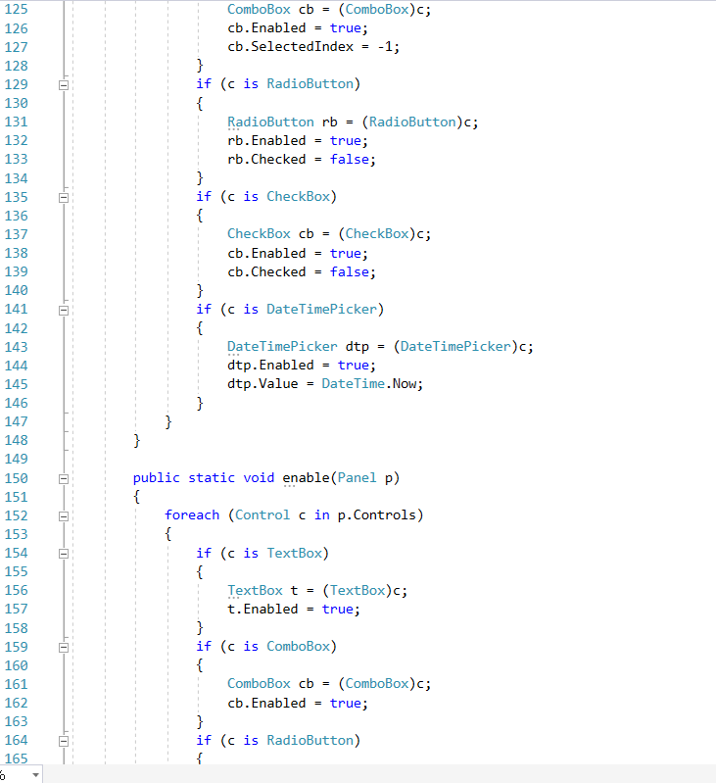

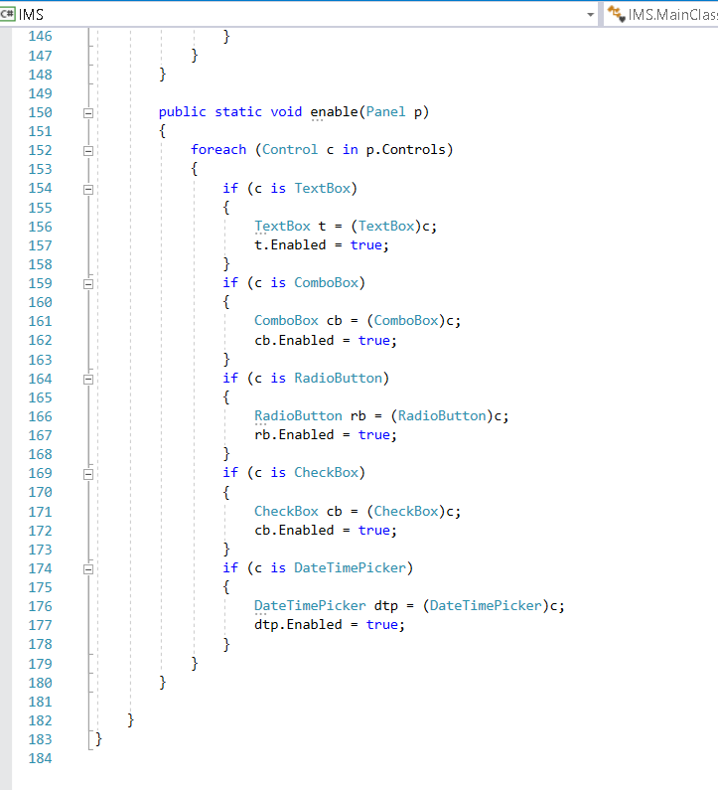

**Database Table with different Queries:**

IMSDB is the name of database that I have created.

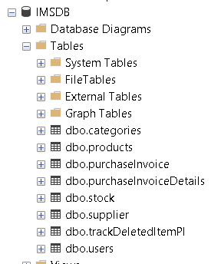The table that are created in the database are shown in the figure.

**System Stored Procedure**

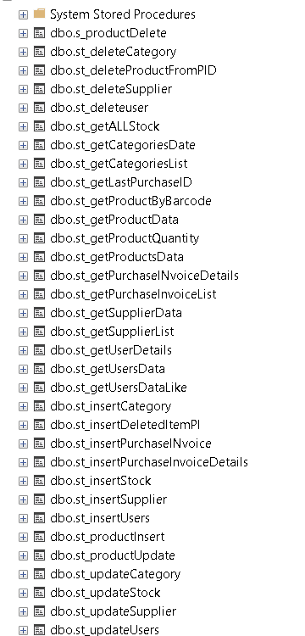

Category Table created in database

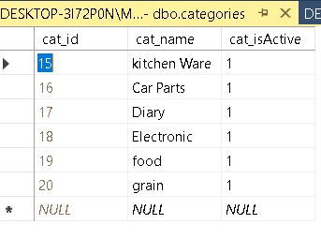

Product Table in database with entry data

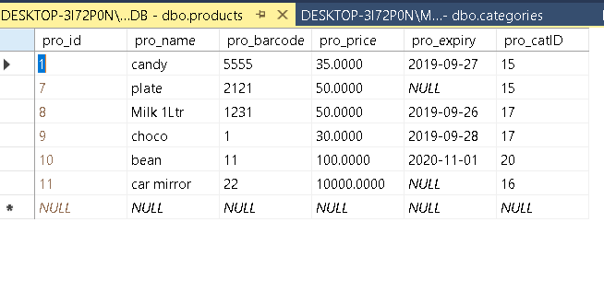

Purchase Invoice table with stored data

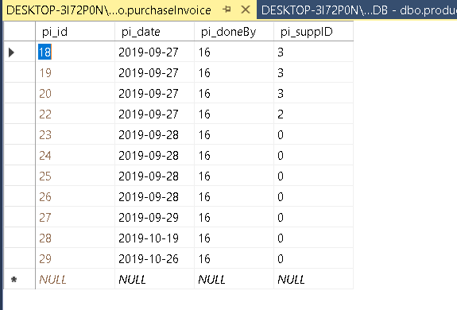

Purchase Invoice Detail table

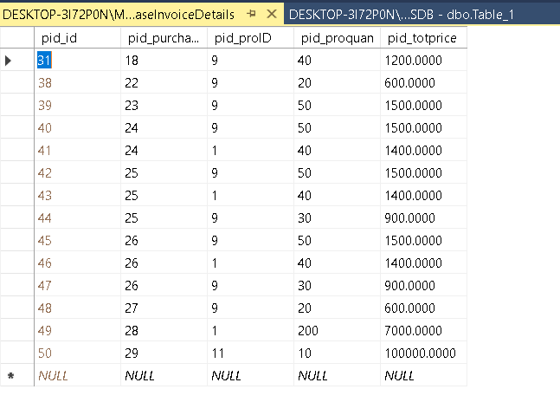

Stock table

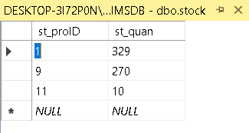

Supplier Table

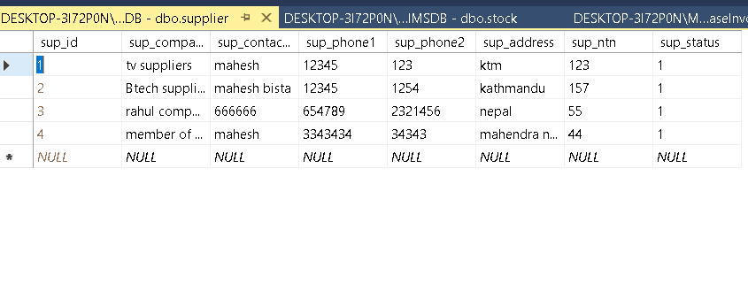

Track Deleted Item

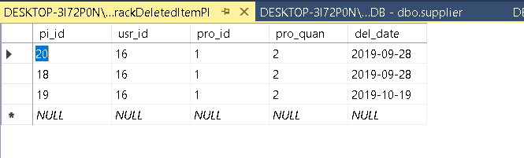

User Table with Stored data. Contain Username and Password.

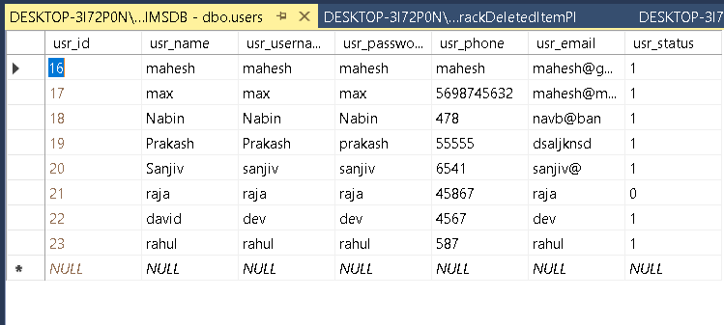

**Table and Procedures Queries**

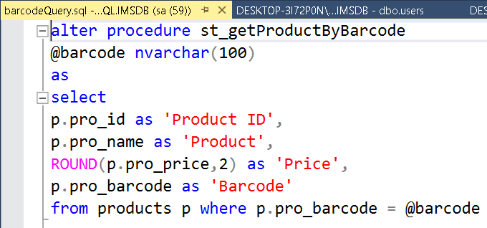

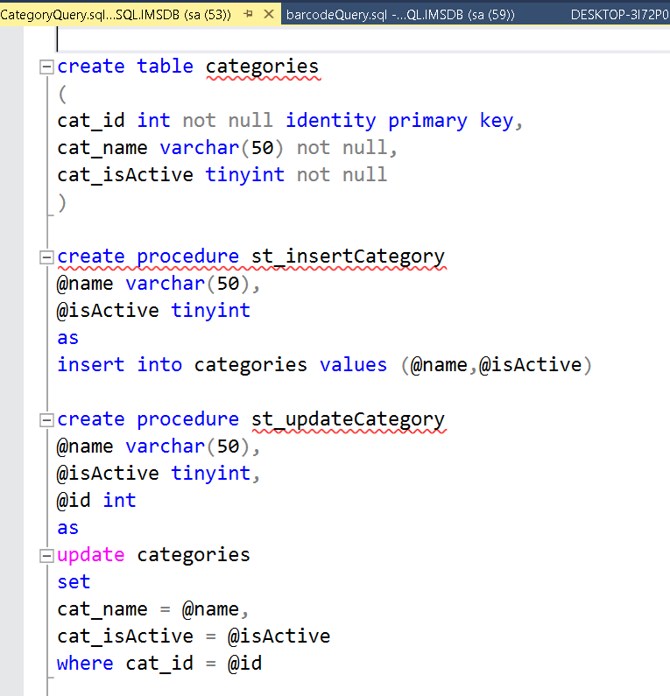

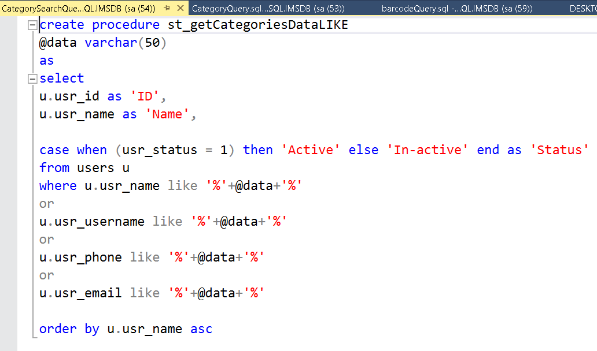

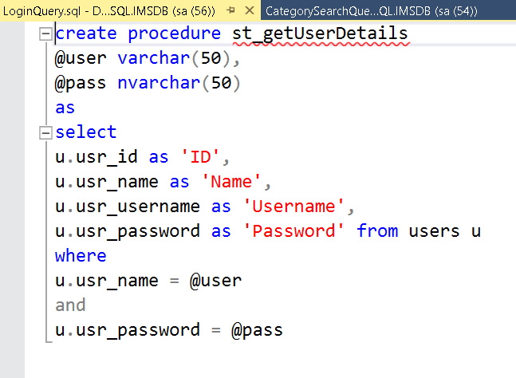

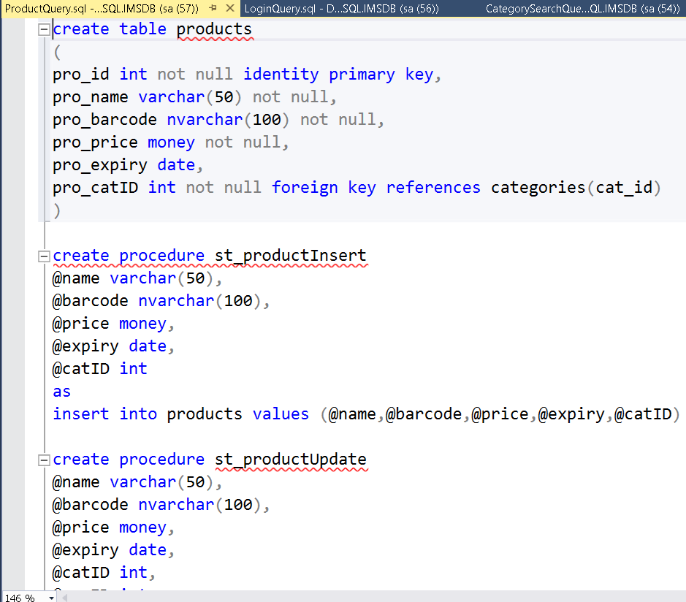

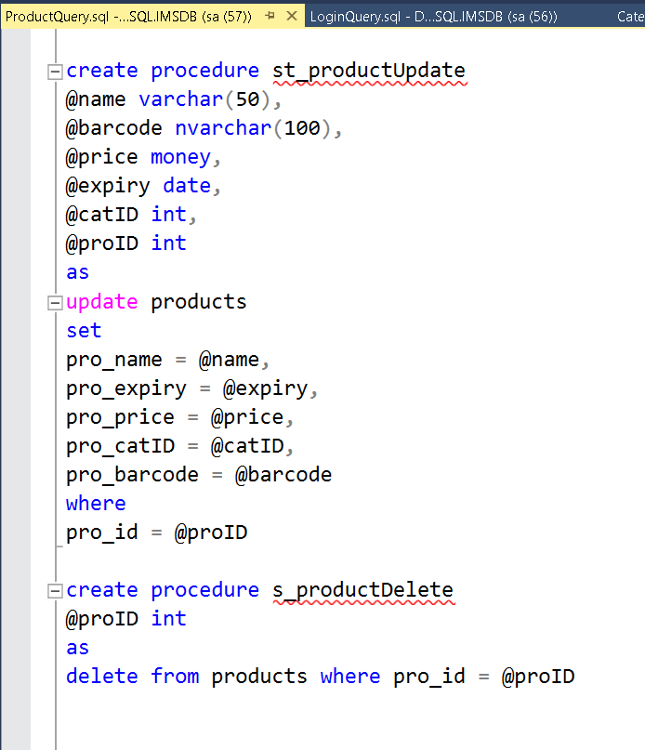

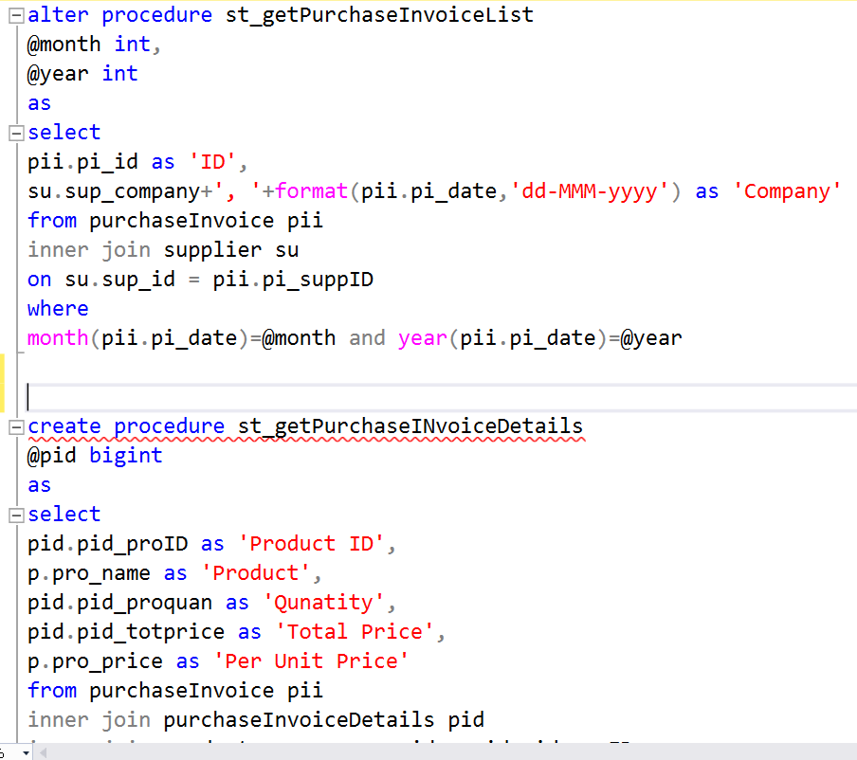

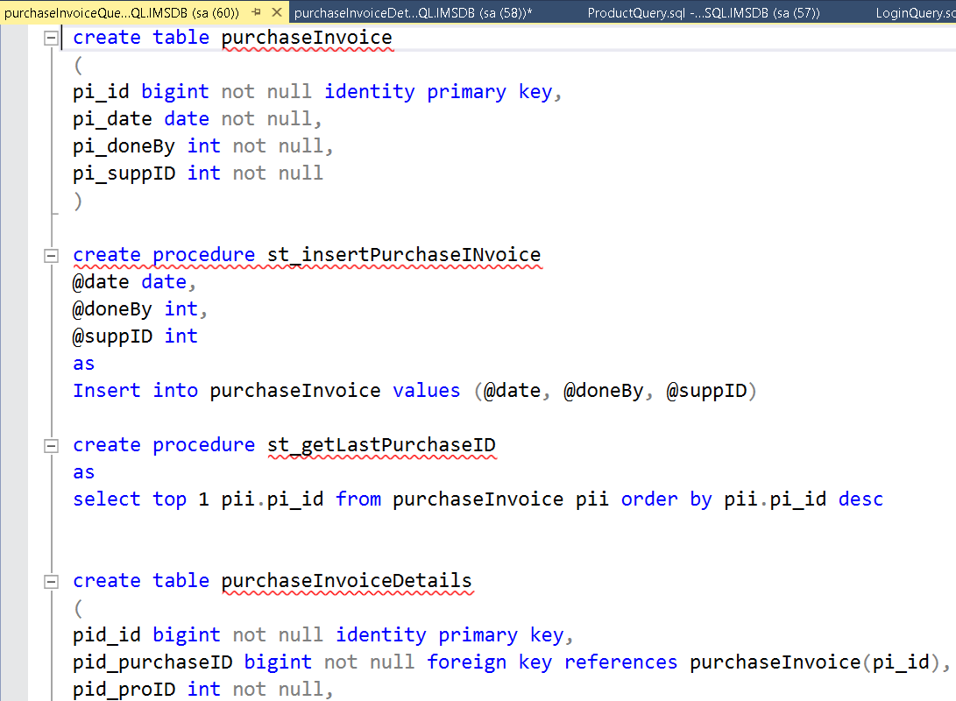

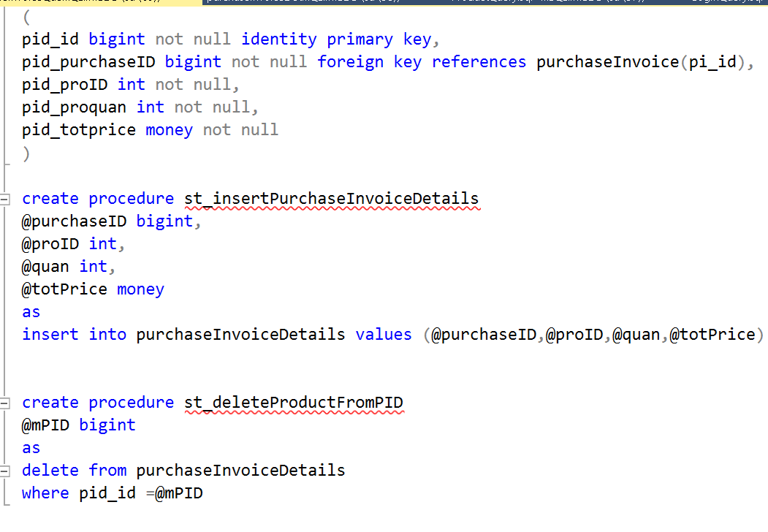

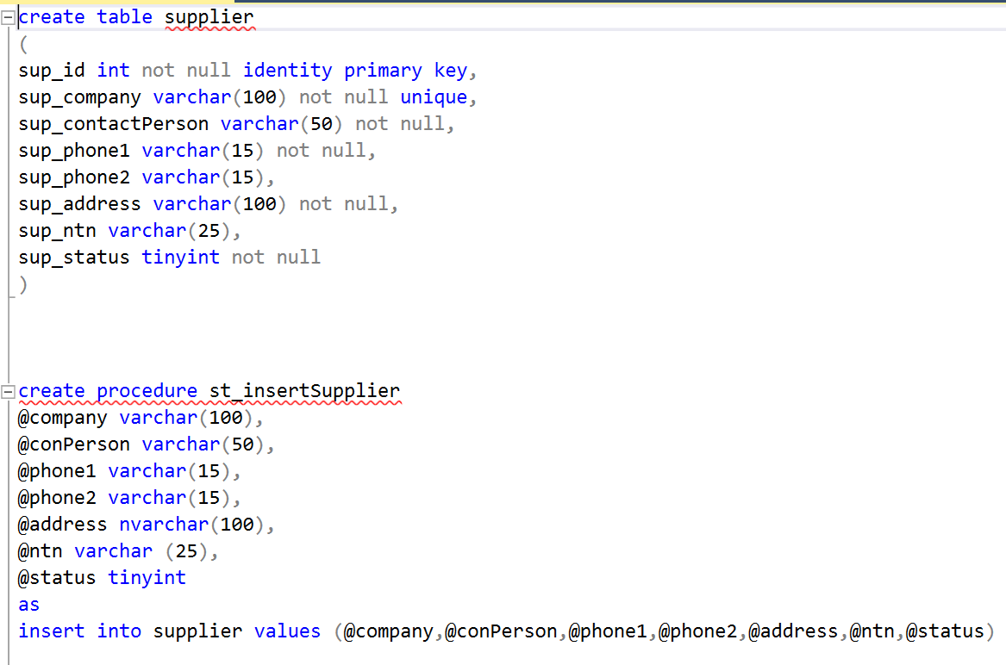

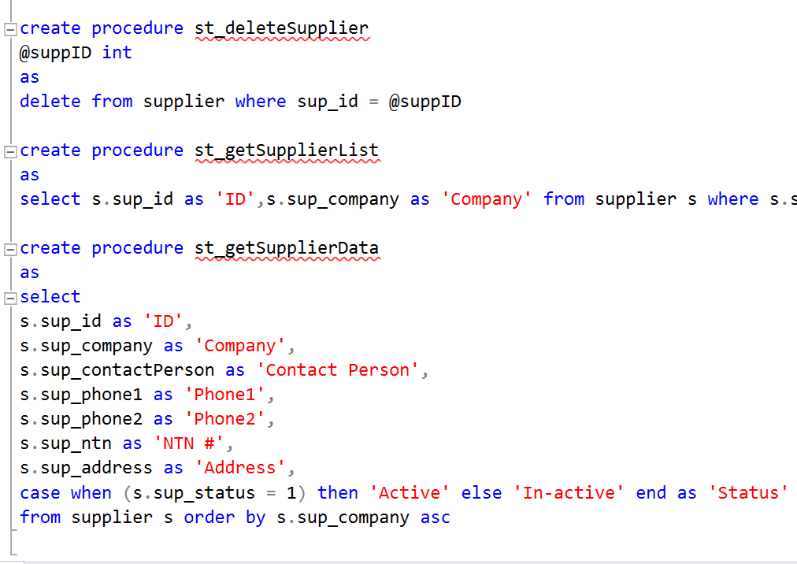

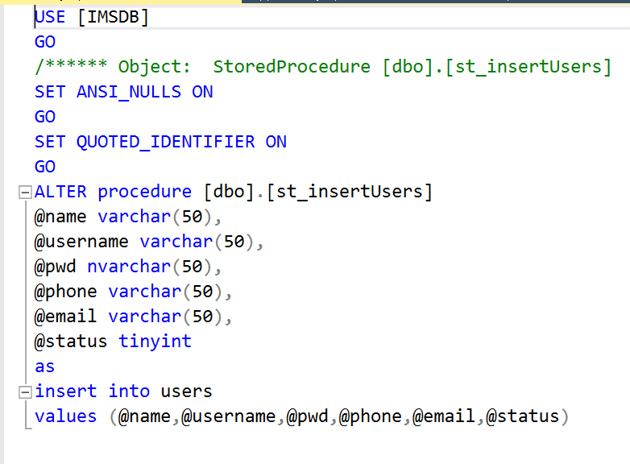

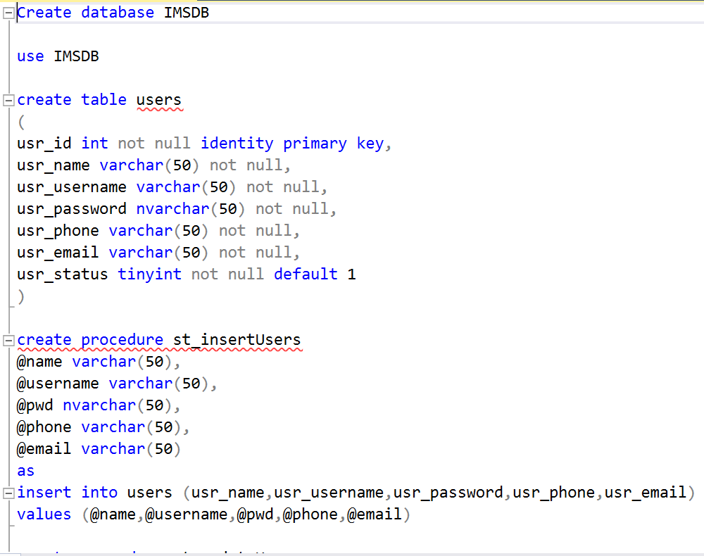



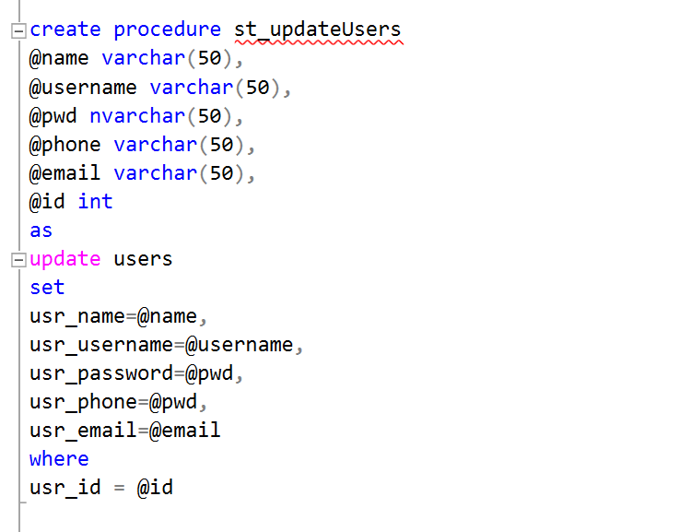

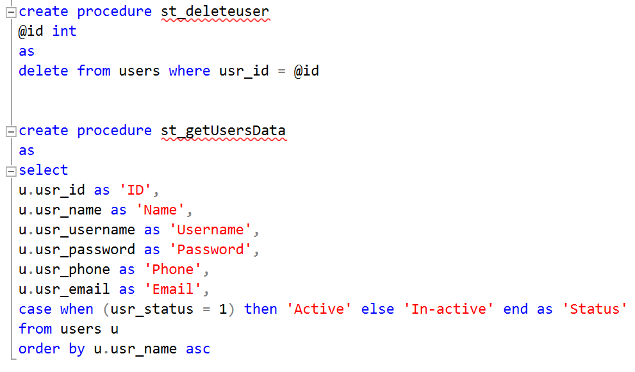

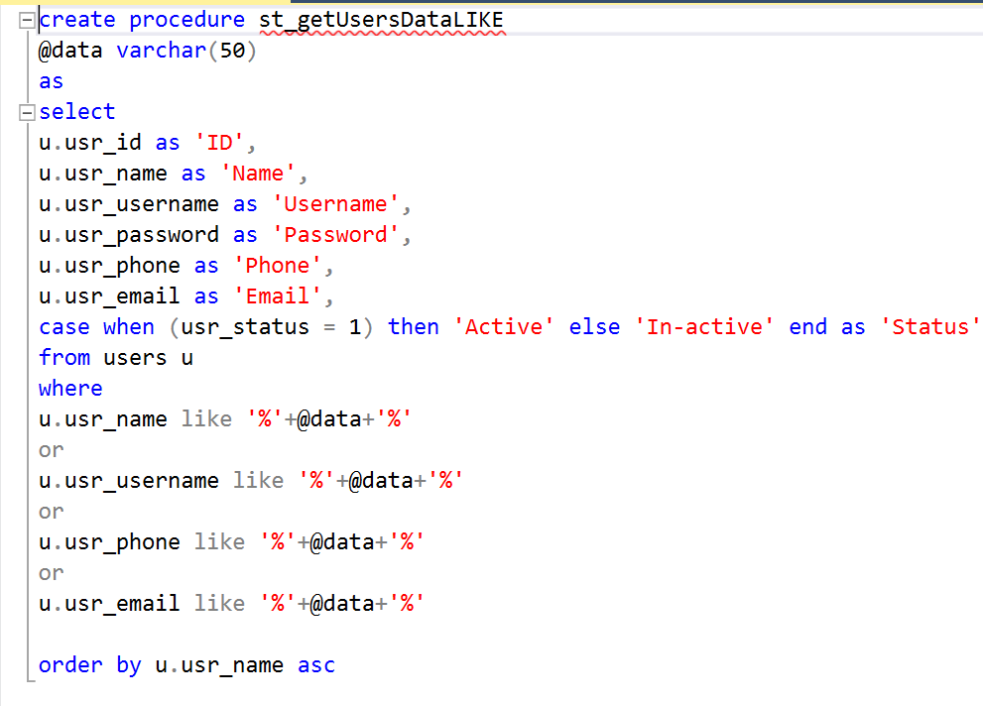

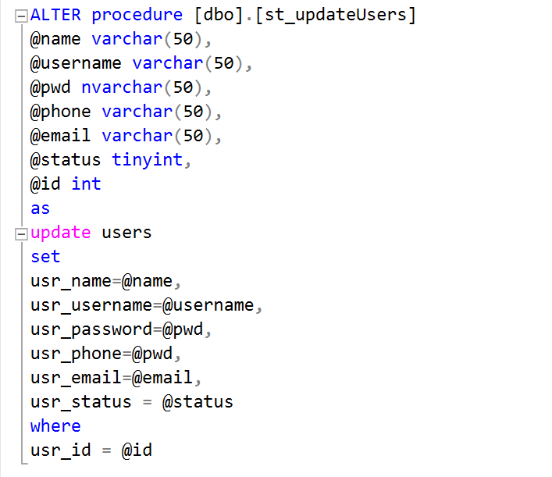

*******************************************Thank you******************************************************